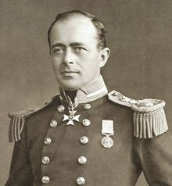
South Pole Explorers:
Robert Falcon Scott

Born: 6 June 1868 Plymouth, Devon, England
Died: 29 March 1912 (aged 43) Ross Ice Shelf, Antarctica
Education: Naval cadet programme, HMS Britannia
Occupation Royal Navy officer and Antarctic explorer

Captain Robert Falcon Scott was an English Royal Navy officer and explorer who died on an expedition to the South Pole.

He is known as Scott of the Antarctic, the title of a 1948 film.

Scott led two expeditions to the Antarctic regions: the Discovery Expedition, 1901–04, and the Terra Nova Expedition, 1910–13.

Before he started exploring, Scott was a navy officer.

Scott led a party of five which reached the South Pole on 17 January 1912, only to find that Roald Amundsen's Norwegian expedition had got there first.

On the return journey, Scott and his travel partners died from exhaustion, starvation and extreme cold.

His expedition is still remembered throughout the world.

