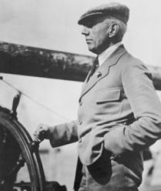
South Pole Explorers:
Roald Amundsen

Occupation: Explorer
Born: July 16, 1872 in Borge, Norway
Died: June 18, 1928 during a rescue attempt
Best known for: First man to visit the South Pole

Where did Roald grow up?
Roald was born in Borge, Norway on July 16, 1872. He grew up in Norway with his three brothers. His father, who was involved with the shipping industry, died when Roald was just 14 years old. Roald had dreamt of becoming an explorer, but his mother wanted him to become a doctor. He followed his mother's wishes until she died when he was 21 years old. Then he left school to pursue his dream of exploring.
Roald became a crewmember on various ships traveling to the Arctic. In 1887 he was first mate on a ship named the Belgica. It became the first expedition to survive the winter on the Arctic. Roald learned valuable lessons of survival during these early trips that would help him later on. One was that fresh seal meat had vitamin C which would help in curing scurvy. Another was to use animal skins rather than wool coats to keep warm.

South Pole
Roald next planned an expedition to reach the North Pole. However, when he heard that Robert Peary claimed to have already reached the North Pole, he made last minute plans and decided to pursue the South Pole. He kept this a secret until the last minute. He was in a race with British explorer Robert Scott to be the first to the South Pole. On January 14, 1911 Amundsen's ship, the Fram, arrived at the Bay of Whales in Antarctica. They set up camp there and prepared for the trip to the South Pole.

