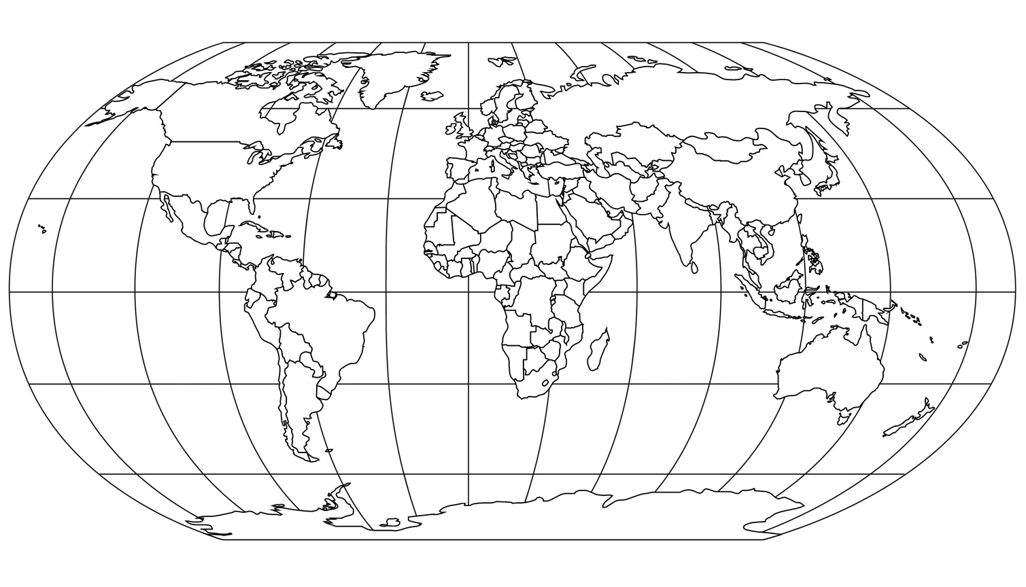
Antarctic Circle
Artic Circle
Tropic of Capricorn
Tropic of Cancer
Equator

Cut each of the labels above out and stick them in the correct place on this map.

