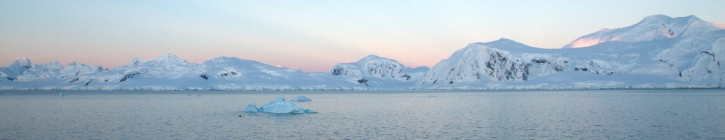
Home learning timetable week beginning 11th January.

Please note that in line with government expectations, children should be completing at least 3 to 4 hours of home learning a day, we have added a guide to how much time should be spend on each learning task.

The maths and English lessons will need to be completed in the order set, the afternoon lessons for each week can be completed in any order.
Please add completed work to children’s portfolio on ClassDojo where your teacher can view and offer any feedback.
Please remember to do TTRockstars, Reading Eggs (and Phonicsplay if your teacher has asked you to) daily.

 | 45-60 minutes  Maths: | At 9.45 AM  60 minutes | 45-60 minutes  English: | 15 mins | 45-60 minutes
Monday | Subtract 2 mixed numbers.  Video tutorial.  (Powerpoint this is an optional extra that children can work through as a further explanation)  Independent work  Alternative Provision -  Count in Fractions  Powerpoint  Independent work | Every day this week, starting at 9.45, please follow one of the links below to join these literacy sessions.  #SuperSentenceStackers  #MrsC  #EnglishWithMrsC  www.youtube.com/c/thetrainingspace  (Please see your class Dojo page for more information) | Spellings  (Spellings - additional support) | Mental maths:  Day 1 – Complete both Monday and Tuesday | French (Eating out)  ‘I’m ordering a drink’  Worksheet,  Vocabulary sheet  Audio:  (Follow this link, choose ‘Year 5’ then ‘Eating out’ lesson 1 ‘I’m ordering a drink’. This will let you listen to the phrases on the worksheet.  https://www.cgpbooks.co.uk/resources/ks2-french-audio | PSHE  Investigate different jobs that people I know have.  The world of work PowerPoint
Setting Descriptions:
Candy Land
Focus: what can be smelt/heard/felt.

Powerpoint.
Word Mat.
Additional Support activity.
Extra Additional Support activity.

Tuesday | Multiply fractions by an integer  Video tutorial.  (Powerpoint this is an optional extra that children can work through as a further explanation)  Independent work.  Alternative Provision - Unit and Non-unit Fractions  Powerpoint  Independent Work |  | Setting Descriptions:  Abandoned house  Focus: atmosphere and mood.  Powerpoint  Supporting activity.  Additional Support activity. | Mental maths:  Day 2 – Complete both Wednesday and Thursday | Geography  The Artic and Antartica – Comparing the two poles  PowerPoint  Comparing the Artic and Antartica – YouTube Video  Antartica Fact File  Artic Fact File  Animals of Antartica
Wednesday | Multiply mixed numbers by an integer.  Video tutorial.  (Powerpoint this is an optional extra that children can work through as a further explanation)  Independent work & answers  Alternative Provision -Making the Whole  Powerpoint  Independent Work |  | Setting Descriptions:  Underwater  Focus: figurative language.  PowerPoint.  Additional Support activity.  Handwriting | Mental maths:  Day 3 – Please complete both Monday and Tuesday | Science  Classifying Animals:  PowerPoint  Activity Sheet to print or to use on computer/tablet (if required)  Please watch this clip before you look at Slide 3 on the PowerPoint:  Carl Linnaeus and the Linnean System
Thursday | Fractions of an amount.  Video tutorial.  (Powerpoint this is an optional extra that children can work through as a further explanation)  Independent work & answers  Alternative Provision -Tenths  Powerpoint  Independent Work |  | Setting Descriptions:  Focus: figurative language 2.  PowerPoint.  Additional Support activity.  Metaphor game | Mental maths:  Day 4 – Please complete both Wednesday and Thursday | Computing:  Internet safety PowerPoint  &  Activity (no printing necessary)
Friday | This final fractions lesson is for the children to use what they have learnt to solve problems involving fractions. Children can choose from 1*, 2* or 3* from the link below.  Independent work  Alternative Provision -Counting in Tenths  Powerpoint  Independent Work |  | English Comprehension:  Shackleton’s Journey - Text  Shackleton’s Journey - Questions | Mental maths:  Day 5 – Please complete both Monday and Tuesday | Art/DT:  How to draw a polar bear  (Follow this step-by-step guide)  https://www.youtube.com/watch?v=qcMywH6FKlg  For the more advanced artists among you, try this one: https://www.youtube.com/watch?v=or2I_Jcyzew

*Please contact your teacher if you are not sure of your login.

