Year 6, Term 6, Week 5 Suggested Timetable – ‘Darwin’s Delights!’
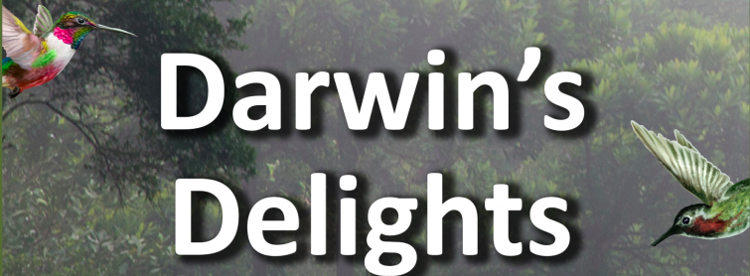
 | Monday | Tuesday | Wednesday | Thursday | Friday
Maths  Online maths games:  NRich  Playground  2048  https://www.kidsmathgamesonline.com  TT Rockstars | This week for maths we will be finishing working through this booklet, with a set number of pages each day. (Answers booklet)
 | Mental Calculations  Pages 16-17 | Factors  Pages18-19 | Prime Number & Multiples  Pages 20 -21 | BIDMAS & FruitShop  Page 22 - 24 | Multistep word problems  Pages 25-27
English  Online Literacy Games:  ReadTheory  Crystal Explorers  Grammar Games  Woodlands  Reading Games | Grammar/Punctuation  Brackets for clauses.  Worksheet  Answers | Comprehension with a sports theme!  Please choose 1*,2* or 3*each day. |  | Rye Writer! – 30-45 minutes a day.  This can be accessed from the Dolphins Class webpage.  Thursday: Planning and Drafting  Friday: Improving and Publishing.  Send us your Rye Writer on ClassDojo
 |  | Jessica Ennis’s biography. | Usain Bolt’s biography.
Topic  These can be completed in any order that you would like to try them in! | Computing  https://studio.code.org/s/express-2019/stage/1/puzzle/1  Use this site to continue to learn to code. Screenshot any animations you create and upload them to Dojo. | PSHE  We will be starting a sequence of transition lessons using resources specifically made for children entering into secondary schools.  This sequence of learning activities is highly recommended as it provides really important discussion points and advice for the children. | Science  Natural Selection  Find out the difference between natural selection and artificial selection (selective breeding). Look at images of mixed-breed dogs to see which features they have inherited from their ‘parent’ dogs. Investigate puggles, schnoodles, chuskys, labradoodles, cockerpoos and dorgis! Consider whether creating ‘artificial evolution’ is the right thing to do and express their opinions.  Note  As an extension activity, children could imagine a new species of dog. What features would they mix and what would it create? | Sports Day!  Please look out for sports day details on Thursday. | SRE  Please see separate email with details and resources from school.

 | Previous week’s learning tasks – Week beginning: Monday 8th June 2020
Geography | Galápagos Tourism Leaflet  Plan an expedition across the Galápagos Islands that will help tourists take in the incredible sights and sounds. Use a range of materials, including online tourism sites to find out about travelling between islands, typical weather conditions, the range of physical and man-made landmarks and features, the local currency, the official language and the best places to stay.  Draw a detailed sketch map of the route, labelling places tourists plan to stop and stay. Make a list of things they would need to take, including clothing that would be suitable for the climatic conditions and physical terrain.
Science | Galápagos Creatures  Chose an animal found on the Galápagos Islands, such as the marine iguana, blue-footed booby, giant tortoise, Galápagos penguin, frigatebird or lava lizard. Consider what features show that the animal has adapted and evolved to suit its environment. Write a short report or presentation, possibly using ICT, to explain your thoughts and ideas.  Note  The blue-footed booby has a sleeker beak and head for a more streamlined shape, which enables it to dive deep into the water to catch fish. Its blue feet help attract a healthy mate.
Science | Science Investigation - Beaks  Investigate how a bird’s beak is adapted to eat specific foods. Fill a series of trays with seeds of varying size and shape, such as sunflower, dried peas, pumpkin, lentils, sesame and poppy seeds. Use pegs, tweezers and chopsticks as beaks to pick up as many seeds from each tray as possible. Record how many they collect with each ‘beak’ and display results graphically. Explain which seeds you collected easily and talk about why and how it relates to bird beak adaptations.  Note  Predict which ‘beak’ will be most suitable for collecting the different seeds. Darwin observed and preserved many finches during his time on the Galápagos Islands. It wasn’t until he returned to England and gave them to an ornithological expert that he found the birds were 13 different species, all evolved from a single ancestor. Each species evolved a different type of beak in order to feed on different things. The evolution of beak shape and size was essential for their survival.
Art | Sketching Outdoors  Work outdoors to sketch plants, flowers and trees, looking carefully to accurately capture their shape, form, pattern and colour. Work in coloured pencil and if available use a hand lens or microscope to examine very fine details. Head back indoors and compare the range of plant and flower species you have drawn.

