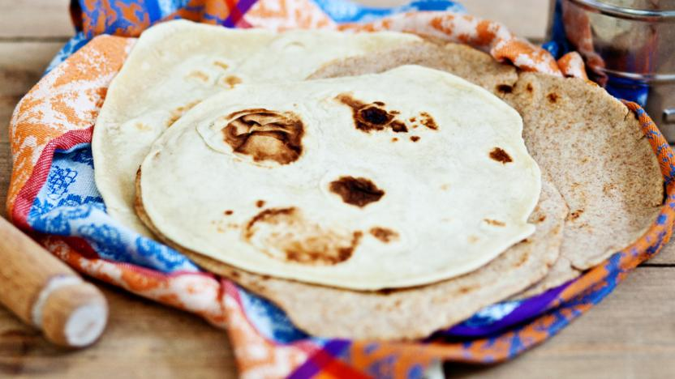
Flatbreads:

Ingredients:
- 200g/7oz plain or wholemeal flour
- ¼ tsp salt
- 100ml/3½fl oz warm water
- 2 tbsp oil (olive, sunflower or vegetable), plus extra for cooking
Method:
- Mix the flour and salt together in a bowl. Add the water little by little.
- Add the oil slowly.
- Knead the dough together. You want the dough to be soft. It is too sticky, add a bit more flour. If it is too dry, add more water.
- Knead the dough for 5 minutes.
- Divide the dough into 4 or 6 balls.
- Sprinkle a little bit of flour onto a surface. Roll each ball of dough into a rough circle using a rolling pin.
- Carefully heat a frying pan with a little bit of oil. Cook each flatbread for 2 minutes on each side.

