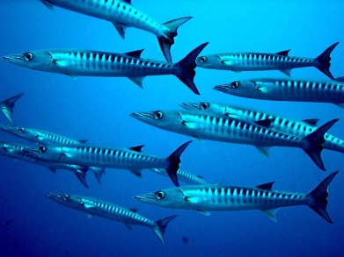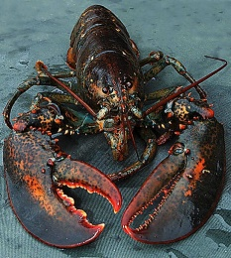

March 2020
Dear parents, carers and guardians,
This is to support your child when they are learning home. Please find attached a pack of English, maths, science and topic resources and ideas to home-school your child.
This work is set for all children who are well enough to continue their learning. The pack contains enough work for the duration of their time at home.
Thank you for your support.
Kind regards,
Miss Brassleay and Mrs Edwards

English:
Reading
Please listen to your child read for at least 15 minutes each day. As this time also allows for talking about the text you will find additional ideas for discussion in this pack along with VIPERS talking-points which have been sent home.

Spellings:
Below are the common exception words for Key Stage 1 and for Year 3 and 4. These can be used for spelling practise and also handwriting. This should be a 20 minute daily activity. Your child might look for these words in their reading.

Check that all words can be read, and break them down into smaller groups to learn. Leave out the words that your child knows and focus on the ones they find trickier.

Common exception words for year 2
1. door  2. floor  3. poor  4. because  5. find  6. kind  7. mind  8. behind  9. child  10. children  11. wild  12. climb  13. most  14. only  15. both  16. old  17. cold  18. gold  19. hold  20. told | 21. every  22. everybody  23. everywhere  24. even  25. great  26. break  27. steak  28. pretty  29. beautiful  30. after  31. fast  32. last  33. past  34. father  35. class  36. grass  37. pass  38. plant  39. path  40. bath | 41. hour  42. move  43. prove  44. improve  45. sure  46. sugar  47. eye  48. could  49. should  50. would  51. who  52. whole  53. any  54. anywhere  55. many  56. clothes  57. busy  58. people  59. water | 60. again  61. against  62. half  63. half-past  63. money  64. Mr  65. Mrs  66. parents  67. Christmas

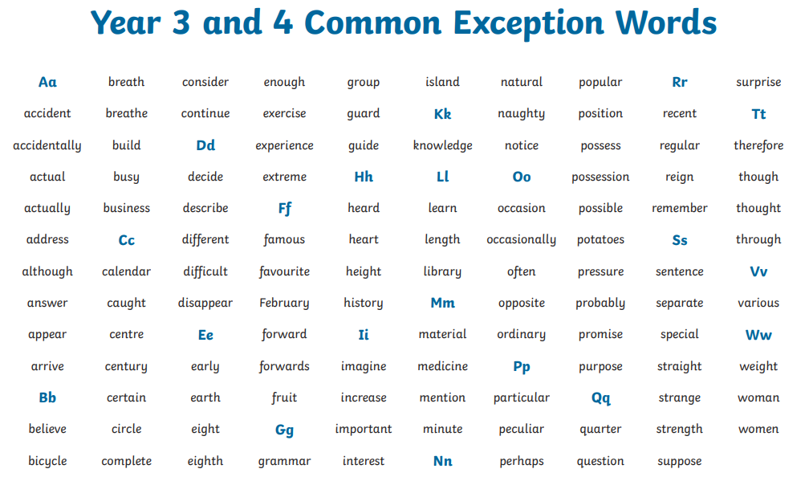

Writing:
Explanation of an earthquake. - 40 minutes a day
Use the plan on the next page to help write an explanation of an earthquake. You can do some research about an earthquake.
Here are some useful websites to help you with your research.
https://www.bbc.co.uk/bitesize/topics/z849q6f/articles/zj89t39
https://www.dkfindout.com/uk/earth/earthquakes/
https://www.ducksters.com/science/earthquakes.php
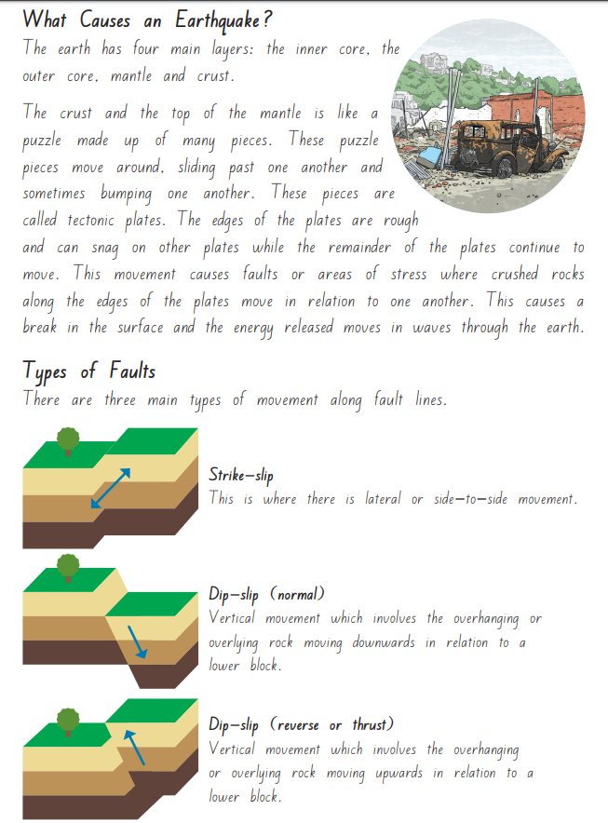
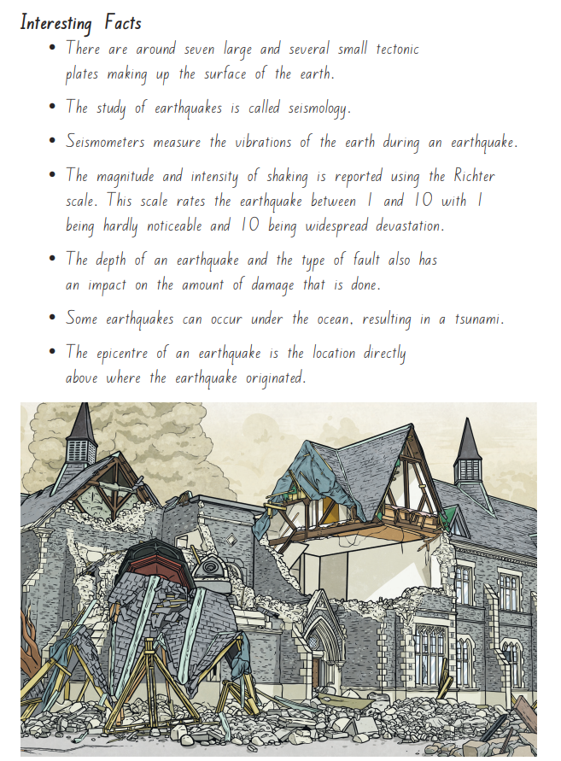
Fill in your plan first and then you can design your own Earthquake Explanation Text.
Check you have used capital letters, full-stops and spelling accurately.

Grammar, Punctuation and Spelling
Please complete one of the SPaG maths once or twice a week. This will help you remember the year 3 key skills.

Maths:
TT Rockstars – at least 15 minutes a day.
All year 3 children have a login for ‘Times Table Rockstars. Please contact the school if you need another copy.
You will find a maths activities which can be used as revision for the topics covered so far.
Try and do 15 minutes of maths every day to keep your brain going.
Science:
This term’s science topic is Plants. These are the objectives we are covering this term:
- identify and describe the functions of different parts of flowering plants: roots, stem/trunk, leaves and flowers
- explore the requirements of plants for life and growth (air, light, water, nutrients from soil, and room to grow) and how they vary from plant to plant
- investigate the way in which water is transported within plants
- explore the part that flowers play in the life cycle of flowering plants, including pollination, seed formation and seed dispersal.
This is a great website to help you learn all about the plants unit of work.
https://www.bbc.co.uk/programmes/articles/Mf5rhbTkHLZ3fbJzScyDvC/primary-science-plants
PLEASE VISIT OUR CLASS PAGES ON THE SCHOOL WEBSITE TO SEE WEEKLY UPDATES FOR LEARNING.
