Maths  Mon-Fri  Should be done in order | Daily times tables practise (TTRockstars)
 | Monday  Hours in a Day 1 | Tuesday  Hours in a day 1 |  |  | Wednesday  Hours in a Day 2 |  | Thursday  Hours in a Day 2 |  |  | Friday  Mental maths activity to help you remember key facts.  https://www.math-salamanders.com/image-files/year-3-mental-maths-practise-b7.gif
English  Mon-Fri  Choose one-a-day.  Rye-Writers is best done on consecutive days. The 2 sessions could be on the same day, then 2 curriculum subjects on the other day. | Daily Reading (15-20 mins) and spelling practice – (Year 3 and 4 Statutory words)
 | 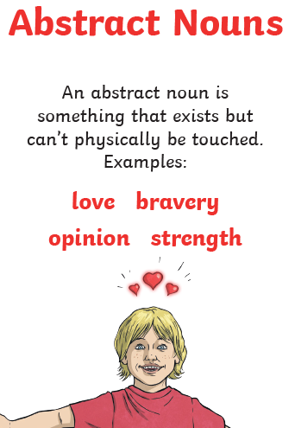  Grammar, Punctuation and Spelling  Nouns – Abstract Nouns. A noun is something you can take a picture of (an object, person, animal, etc). An abstract noun is something you CAN’T take a picture of but you know it is still there.  Abstract Nouns |  |  | Theseus and the Minotaur reading comprehension  Read this different version of Theseus and the Minotaur.  Which version do you prefer and why? This week’s or last weeks? Explain your answer.  Theseus and the Minotaur |  |  |  |  | Rye Writers
Curriculum  Choose one-a-day. | Science  Discovering Reflective Surfaces.  Watch this clip.  https://www.bbc.co.uk/bitesize/clips/zs3ygk7  Then have a go at the “Discovering Reflective Surfaces” activity. |  | ICT  PurpleMash: 2Do |  |  | Art  Look at these images of the Minotaur.  Can you draw/paint/sketch your own picture of the Minotaur?  Don’t trace!  Images of the Minotaur |  | History  Watch this video about the meaning of AD and BC.  https://www.mathsisfun.com/ad-bc.html  Can you order these key events from the time of the Ancient Greeks starting from the earliest event through to the latest event?  Ancient Greek timeline

