Maths  Mon-Fri  Should be done in order | Daily times tables practise
 | Monday  https://whiterosemaths.com/homelearning/year-3/  Week 1 learning  Unit and non-unit fractions | Tuesday  https://whiterosemaths.com/homelearning/year-3/  Week 1 learning  Making the Whole | Wednesday  https://whiterosemaths.com/homelearning/year-3/  Week 1 learning  Tenths | Thursday  https://whiterosemaths.com/homelearning/year-3/  Week 1 learning  Tenths as decimals | Friday  Mental maths activity to help you remember key facts.  https://www.math-salamanders.com/image-files/mental-maths-sheets-year-3-b2.gif
English  Mon-Fri  Choose one-a-day.  Rye-Writers is best done on consecutive days. The 2 sessions could be on the same day, then 2 curriculum subjects on the other day. | Daily Reading (15-20 mins) and spelling practice – (Year 3 and 4 Statutory words)
 | Grammar, Punctuation and Spelling  Writing Direct Speech | Comprehension  “Tom’s Exciting Morning”  Day 1 – Reading text.  Day 2 – Answer questions | Rye Writers  Rye-Writers is best done on consecutive days to give the children a break. You can also choose to do the 2 sessions on the same day, and 2 other curriculum subjects on the other day.
Curriculum  Choose one-a-day. | Science  Watch these video clips below about food chains.  https://www.bbc.co.uk/bitesize/topics/zbnnb9q/articles/zwbtxsg  https://www.youtube.com/watch?v=hLq2datPo5M  Now create 2 of your own food chains, explaining what a ‘producer’ and ‘consumer’ is.  Make sure you start with a producer and add 2 or 3 consumers. | Geography  Find out about Habitats on this website:  https://www.theschoolrun.com/homework-gnome-geography  Choose your favourite habitat, read about it and then write the main facts about that habitat in your own words.  Can you draw a food chain including a producer and consumer from your chosen habitat? | ICT | Art  Choose your favourite animal and draw, sketch or paint a close up of its eyes.  Really try and get as much detail as possible. You can upload you pictures to Class Dojos.  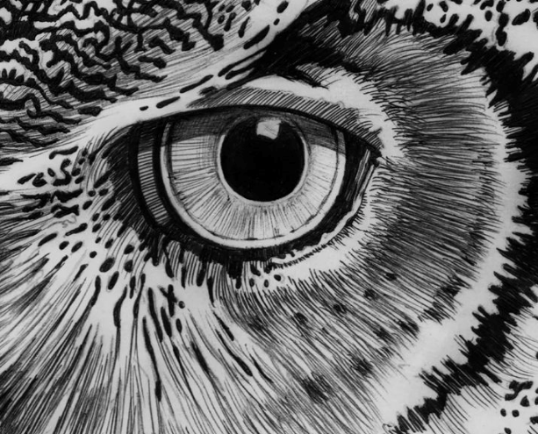  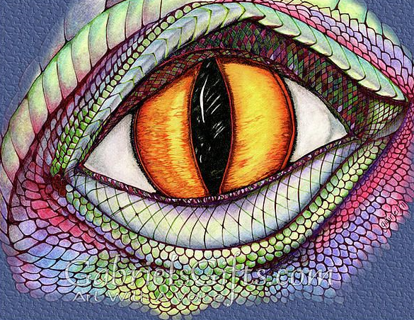 | French  Learn to count to twenty in French.  Can you introduce yourself in French and ask what someone’s name is?  “Je m’appelle Miss Brassleay.  Comment t’appelles-tu?”

