Reflection

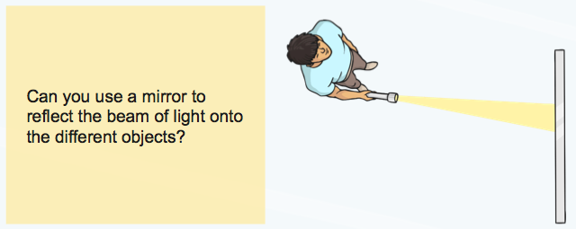

You will need:

- A torch
- A mirror
- A piece of paper or a flat object of your choice
- A partner!

Have your partner hold the piece of paper in front of them facing the mirror. They need to stand just to the side.

Stand next to your partner.

Shine your torch onto the mirror. Can you get the beam of light to reflect onto the piece of paper?

Now try having your partner move the piece of paper. Can you get the beam of light to reflect on the paper again?

---

Now have a go at answering these questions:

What happens when you shine a light onto a mirror?

When you shine a light source on the mirror does it always reflect in the same direction? What can you do to change the direction?

