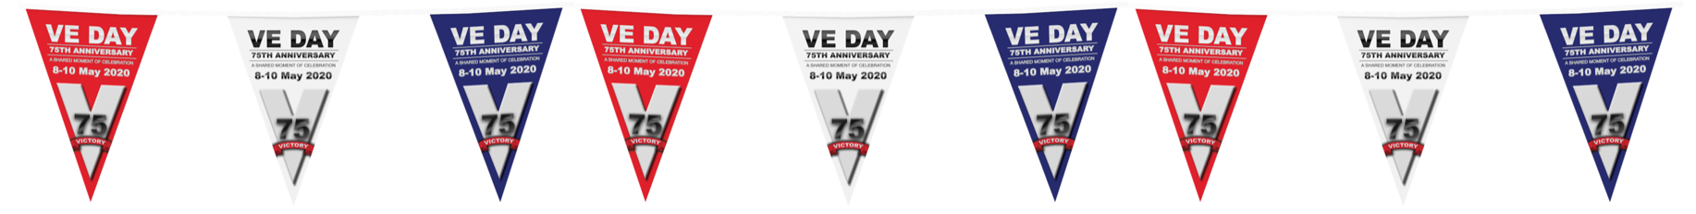
Unhappy
Cuddly
Adorable
Beloved
Cute
Huggable
Kind
Lovable
Gentle
Favourite

Rye Writers:
Worn
Tattered
Tatty
Shabby
Stuffed
Plump
Used
Soft
Padded
Squishy

Journey of an Evacuee Teddy Bear

