[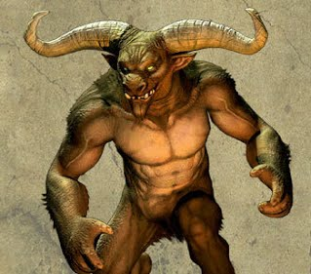](https://sites.google.com/site/basicgreekmythology/monsters-and-creatures/minotaur)[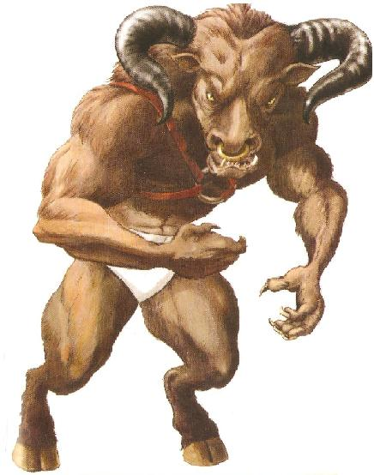](https://www.google.co.uk/url?sa=i&url=https%3A%2F%2Friordan.fandom.com%2Fwiki%2FMinotaur&psig=AOvVaw2E3Al6dRdNSYs_18OF3Vtt&ust=1591276624162000&source=images&cd=vfe&ved=0CAIQjRxqFwoTCODYiLHd5ekCFQAAAAAdAAAAABAJ) [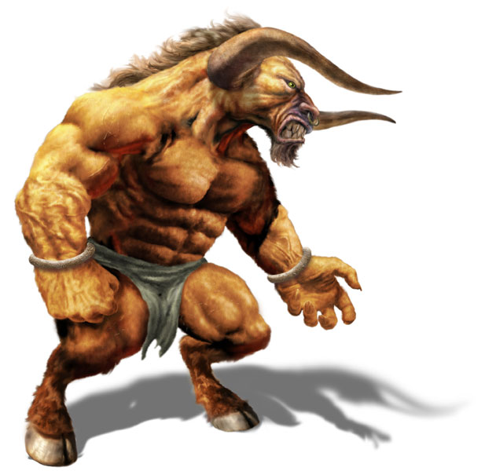](https://www.google.co.uk/url?sa=i&url=https%3A%2F%2Fmattwyles.wordpress.com%2F2014%2F10%2F21%2Fminotaur-imagery-collection%2F&psig=AOvVaw2E3Al6dRdNSYs_18OF3Vtt&ust=1591276624162000&source=images&cd=vfe&ved=0CAIQjRxqFwoTCODYiLHd5ekCFQAAAAAdAAAAABAP)

[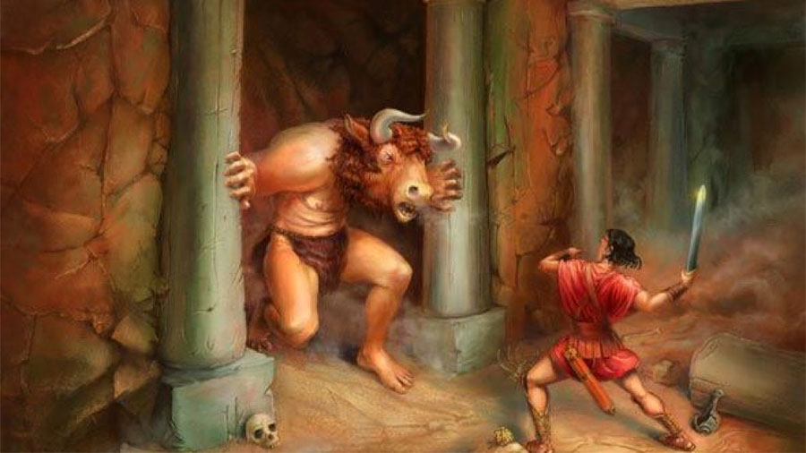](https://www.google.co.uk/url?sa=i&url=https%3A%2F%2Fknossosguides.com%2Fblog-view.php%3Fid%3D53&psig=AOvVaw2E3Al6dRdNSYs_18OF3Vtt&ust=1591276624162000&source=images&cd=vfe&ved=0CAIQjRxqFwoTCODYiLHd5ekCFQAAAAAdAAAAABAn)[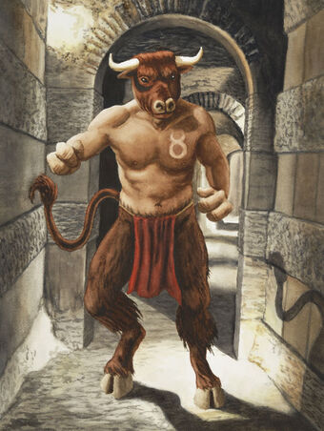](https://www.google.co.uk/url?sa=i&url=https%3A%2F%2Fmonster.fandom.com%2Fwiki%2FMinotaur&psig=AOvVaw2E3Al6dRdNSYs_18OF3Vtt&ust=1591276624162000&source=images&cd=vfe&ved=0CAIQjRxqFwoTCODYiLHd5ekCFQAAAAAdAAAAABAh)[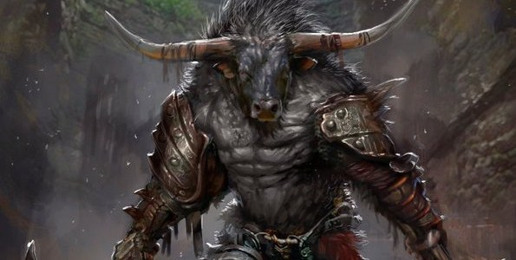](https://www.google.co.uk/url?sa=i&url=https%3A%2F%2Fdmdave.com%2Ftorax-minotaur-barbarian%2F&psig=AOvVaw2E3Al6dRdNSYs_18OF3Vtt&ust=1591276624162000&source=images&cd=vfe&ved=0CAIQjRxqFwoTCODYiLHd5ekCFQAAAAAdAAAAABAV)