Positive Behaviour policy


ACADEMIC YEAR: | 2017/2018
Headteacher: | Jane Howard

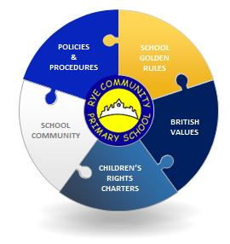

TABLE OF CONTENTS

1. Parties involved 3
2. Introduction – Our Rights Respecting School 4
3. Role of Children 5
4. Role of parents 5
5. Role of Staff 5
7. Role of the Head 6
8. Role of Governors 6
9. Off site Outings / Trips 7
10. Monitoring 7
11. Our 5 Questions: 8
12. Consequences 9
13. Golden Rules 10
14. Exclusions 10
15. Bullying Incident Report Form 11

Revision Record
Rev | Date | Section | Page | Reason
0 | 1/1/2017 | Identify relevant section. | Inset number in relation to change. | Make a brief reference to any changes within the document, Including the reason for the change.
1 | 28/09/2017 | Front page, Table of contents, Parties Involved and Exclusions – all added to document | 1, 2, 3, 6, 10 | General tidy up and improve format. Addition of Point 6 Early Years and Point 14, Exclusions.

Doc  Number | Other Related School Policies | Document Type
 | Admissions Policy | Rye Academy Trust Policy
 | Attendance Policy | Rye Primary School Policy
 | Charging & Remissions Policy | Rye Primary School Policy
 | Children with Medical Conditions Policy | Rye Academy Trust Policy
 | Complaints Policy | Rye Academy Trust Policy
 | Equal Opportunities Policy | Rye Academy Trust Policy
 | Health & Safety Policy | Rye Academy Trust Policy
 | Keeping Children Safe in Education Guideline | Department of Education
 | Positive Behavior Policy (this policy) | Rye Primary School Policy
 | Preventing Extremism and Radicalization Safeguarding Policy | Rye Academy Trust Policy
 | Safer Recruitment Policy | Rye Academy Trust Policy
 | Safeguarding and Child Protection Policy | Rye Academy Trust Policy
 | Teaching and Learning Policy | Rye Primary School Policy

Parties involved
Rye Primary School and Pugwash Nursery sit under the Rye Academy Trust (RAT) umbrella. In some cases, policies and procedures will cover the entire Academy Trust. More specific requirements will be detailed within Rye Primary Policies.




Rye Academy Trust
The grove
Rye
East Sussex
TN31 7NQ
(01797) 222545

Rye Community Primary School
The Grove
Rye
East Sussex
TN31 7ND
01797 222825
Email:
office@ryeprimary.co.uk

Pugwash Nursery
Love Lane
Rye
East Sussex
TN31 7NQ
01797 222009
pugwash@ryeprimary.co.uk

Introduction – Our Rights Respecting School
The consistent application of agreed school policies and procedures are key to a successful school. Expectations and boundaries are clear. By adopting a consistent approach throughout the school, we provide a safe and pleasant environment where children feel motivated to learn, achieve, and are able to develop morally, socially and spiritually.

It is the policy at Rye Community School to build positive relationships between all members of the school community, treating one another with respect at all times.

A continuous and consistent emphasis on praise and encouragement is the prime incentive to promote these positive relationships, which in turn nurture the kinds of behaviour we can all be proud of.

We are a community committed to the belief that we can make a difference for the life chances of our children. Everyone within the school is encouraged to understand they have rights and responsibilities and that it is everyone’s right to be treated respectfully and everyone’s responsibility to ensure that their behaviour is appropriate to enable learning to take place. We believe that quality opportunities that develop all children’s learning skills will positively affect their behaviour.

As adults we lead by good example and set high standards. We follow a PSHE programme based on SEAL in order to ensure pupils have the necessary skills to work well in a community. We are a Rights Respecting School and have selected the following six Articles from the United Nations Convention on the Rights of the Child to focus on across the school.

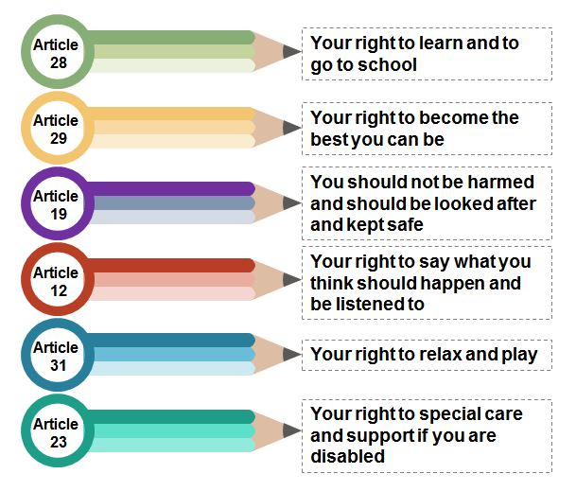
We use a system of rewards and sanctions, which involve early liaison and continued partnership with parents, in the aim to improve and maintain good behaviour.

We take into account individual needs and provide support in order that all children follow this policy.

Role of Children

The children promise to keep the Golden Rules
“We would like everybody who comes to Rye Community Primary School, pupils, parents, school staff and visitors, to be kind, polite motivated and respectful people who always aim for GOLD!”

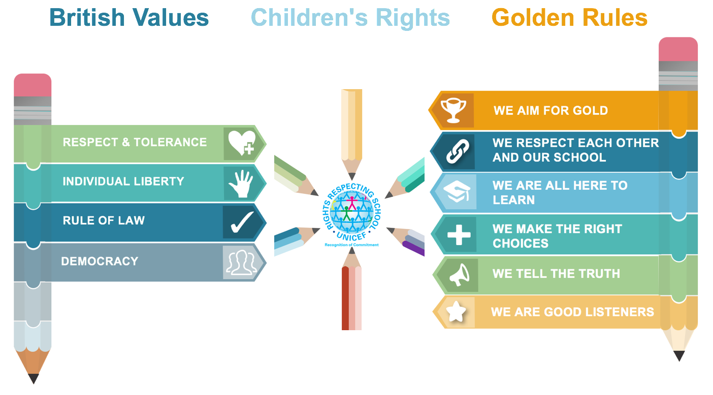

Role of parents

The school works collaboratively with parents, so children receive consistent messages about how to behave at home and at school. We explain the school Golden Rules in the school prospectus and school website, and we expect parents to read these and support them.
We expect parents to support their child’s learning, and to co-operate with the school, as set out in the home–school agreement. We try to build a supportive dialogue between the home and the school, and we inform parents immediately if we have concerns about their child’s welfare or behaviour.

If the school has to use reasonable sanctions to punish a child it is essential that parents should support the actions of the school. If parents have any concern about the way that their child has been treated, they should initially contact the class teacher. If the concern remains, they should contact the school governors. If these discussions cannot resolve the problem, a formal grievance or appeal process can be implemented.

Role of Staff

The adults encountered by the children at school have an important responsibility to model high standards of behaviour, both in their dealings with the children and with each other, as their example has an important influence on the children.

As adults we should aim to:
• create a positive climate with realistic expectations;
• emphasise the importance of being valued as an individual within the group;
• promote, through example, honesty, courtesy and following the Articles for the Rights of the Child;
• provide a caring and effective learning environment;
• encourage relationships based on kindness, respect and understanding of the needs of others;
• ensure fair treatment for all regardless of age, gender, race, ability and disability;
• show appreciation of the efforts and contribution of all and acknowledge that we learn from our mistakes.

All teachers are responsible for dealing with incidents in and around school. They can refer to senior management team, Inclusion Leader and ultimately to the Head to request support.

- In the Early Years

All adults within the Early Years promote positive relationships between the children, staff and parents. Early Years practitioners have specialist knowledge in supporting the youngest of children to develop their social skills, and manage their own behaviour. Early Years practitioners are skilled in negotiating behaviour which can be age appropriate.
Any incidents of behaviour are recorded and tracked by the Nursery Manager and this information is used to identify any potential triggers or trends. The Nursery Manager makes the decision to raise concerns with other professionals in regards to behaviour, but will always discuss this with parents or carers first.
Staff use a range of techniques and resources to support children in learning to recognise and manage their feelings.

Role of the Head

It is the responsibility of the Headteacher to implement the school behaviour policy consistently throughout the school, and to report to governors, when requested, on the effectiveness of the policy. It is also the responsibility of the Headteacher to ensure the health, safety and welfare of all children in the school.
The Headteacher supports the staff by implementing the policy, by setting the standards of behaviour, and by supporting staff in the implementation of the policy. The Headteacher keeps records of all reported serious incidents of misbehaviour and has the responsibility for giving fixed-term exclusions to individual children for serious acts of misbehaviour. For repeated or very serious acts of anti-social behaviour, the Headteacher may permanently exclude a child.
Both these actions are only taken after the school governors have been notified.

Role of Governors

The governing body has the responsibility of setting down these general guidelines on standards of discipline and behaviour, and of reviewing their effectiveness. The governors support the Headteacher in carrying out these guidelines.
The Headteacher has the day-to-day authority to implement the school behaviour and discipline policy, but governors may give advice to the head teacher about particular disciplinary issues. The Headteacher must take this into account when making decisions about matters of behaviour.
The Governors should follow the normal grievance procedure in cases of complaint.

Off site Outings / Trips

- When classes are off site we expect all pupils to follow this Behaviour Policy.

- To ensure the safety of all pupils, parents may be asked to accompany their child on outings / trips once they have a successful DBS application.

For positive behaviours children are rewarded with:

- ‘Raffle’ Tickets for good learning behaviour and following Rye Primary’s ‘Golden Rules’. Tickets will be entered into a weekly class lucky dip.

- Each class has a Golden Trophy awarded in Friday Assembly, to the child who has consistently met the whole school Golden Rules for the week. The achievement is shared with the whole school in Assembly and in all classes through the week.

- The class Number Muncher and Greedy Reader are awarded weekly within the class.

- Surprise certificates will be posted home to notify families of good learning behaviour or attitudes.

- Prefects Award is given weekly to a class who have achieved the selected target.

Monitoring

To succeed, the system needs to be applied consistently by teaching and non-teaching staff alike.
Children’s behaviour will be monitored through:

- A record of Golden Trophy winners is kept, with the class trophy awarded permanently to the child with the highest score at the end of the year.

- A record of pupils attending detention. 5+ detentions leads to interview with Inclusion Leader, Deputy Headteacher and parent and further monitoring.

- Additional Needs Plans and Education Health Care Plans, along with Provision Maps.

- Individual risk assessments.

Consistency of the system will be monitored by:

- A termly review of the number of pupils attending from different referral sources and for what reason.

- A report to the Governing Body regarding the success of the scheme.

Our 5 Questions:

It has been agreed that all adults dealing with an incident will consistently ask the 5 questions below:

OUR 5 QUESTIONS

- What’s happened? (Why?)

- How do you feel?

- What could you do?

- What should you do?

- How are you going to do that and would you like some help?

Consequences

Two positive comments for desired behaviour to a group or the whole class will be made before consequences are followed with an individual.

Action | Consequence
- Positive comments made by adults to model good choices
- A verbal warning
- Child’s name written on board | Child can achieve a clean slate for correct choice of behaviour. (Children cannot request this)
- One tick against name | Detention of 5 mins from following playtime (Y6 full 15mins) outside the HT office. Class teacher to inform parent by face-to-face, phone call or home-school book.
- Two ticks against name | All following playtime in detention outside HT office. Class teacher to inform parent by face-to-face, phone call or home-school book.
- Three ticks against name | Yellow slip completed.  Child sent to the Head and child completes a 4W form with HT, where they may remain placed for rest of morning/afternoon.  All of the following playtime in detention.
- Serious incident i.e. complete defiance, verbal abuse, deliberate damage to property or physical aggression to child or adult | Red removal slip completed. Staff to call extension 201 for member of the Leadership Team to remove child.  Appropriate action taken.  Headteacher will contact parent by phone or face to face.

Any behaviour issues will be constantly logged by the Leadership Team. Any ongoing low level behaviour will be discussed with parents on the phone or face to face by the class teacher.

Specific children may not receive a following playtime sanction (eg. Pupils with ASD, Communication difficulties) but will be spoken to immediately about their behaviour. The behaviour policy is written in accordance of Section 89 of the Education and Inspections Act 2006.

Golden Rules
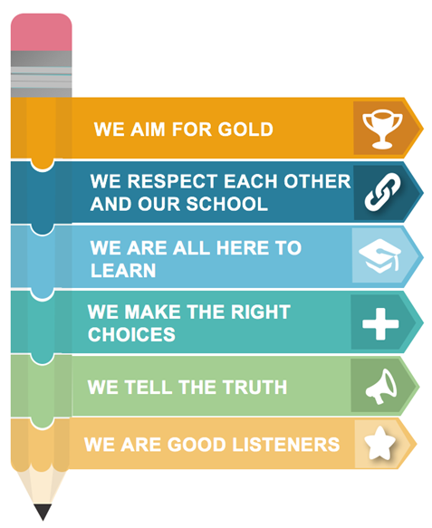

Exclusions

Due to the above policy and procedures we have very few exclusions of any kind and are well below national average.
The Headteacher will make the decision if an exclusion is necessary, following East Sussex County Council procedures and informing Rye Academy Trust Board of Trustees.
All exclusion cases should be treated in the strictest confidence. Only those who need to know the details of the exclusion should be informed of them. East Sussex Education, Support, Behaviour and Attendance Service should be informed of all permanent exclusions.

Appendix

Bullying Incident Report Form

Reported by: Role:

Date(s) of incident(s):

Time(s) of incident(s):

Location(s) of incident(s):

Details of people involved
Please include names, genders, ages, ethnic origin, and children in care or children with special needs and each child’s role – ringleader, outsider, reinforcer, assistant, defender, victim – and the level of involvement.

1 = very involved 2 = involved 3 = slightly involved 4 = only indirectly involved

Bullying incident related to: tick all that apply

Race Appearance or health condition

SEN or disabilities Sexual orientation

Gender Religion or culture

Age Other (define)

Forms for bullying used: tick all that apply

Physical aggression Damaging or taking personal possessions

Deliberately excluding Verbal threats

Name calling and teasing Spreading rumours

Cyber bullying Extortion

Other (define)

Frequency and duration of bullying behaviour:

Once or twice Persisting over two months

Several times a week Persisting for more than a year

Other notes on incident: including relevant previous behaviour

Checklist: tick as appropriate

Does incident involve same person? Has a follow up date been set?

Have parents / carers been notified? Has action been agreed with victim?

Had individual discussions with all? Has action been agreed with perpetrator?

Had group discussion with all involved? Are notes and comments attached?

Other actions:

Medical treatment required? Referral to other agencies?

Police involvement? Specific report from staff attached?

Report to governors? Other?

Details of actions agreed with everyone involved – including parents and carers where appropriate:

Follow up review dates and interventions:

Completed by:

Role: Date:

Checked by:

Role: Date:

Outcome of follow up and further actions taken:

Has the bullying stopped? Yes No

Describe any other outcomes, who was involved and when they occurred:

