17.5.21
L.I: To use my observations to say what food crops will need to grow and stay healthy.
Steps to success
*I can explain that different plants have different needs.
*I can give examples of food crops.
*I can say how to care for food crops so they grow well.
Farmers grow plants that we eat. Draw the plants that you would like to grow on your farm.
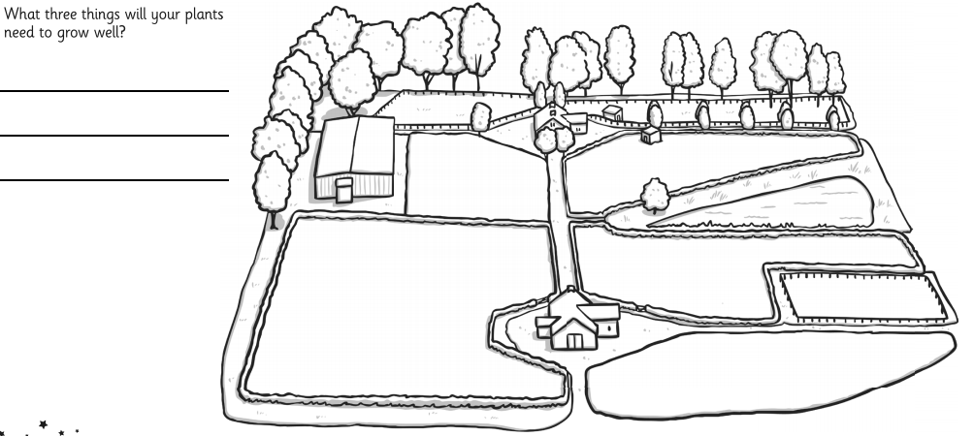

17.5.21
L.I: To use my observations to say what food crops will need to grow and stay healthy.
Steps to success
*I can explain that different plants have different needs.
*I can give examples of food crops.
*I can say how to care for food crops so they grow well.
Farmers grow plants that we eat. Draw the plants that you would like to grow on your farm.
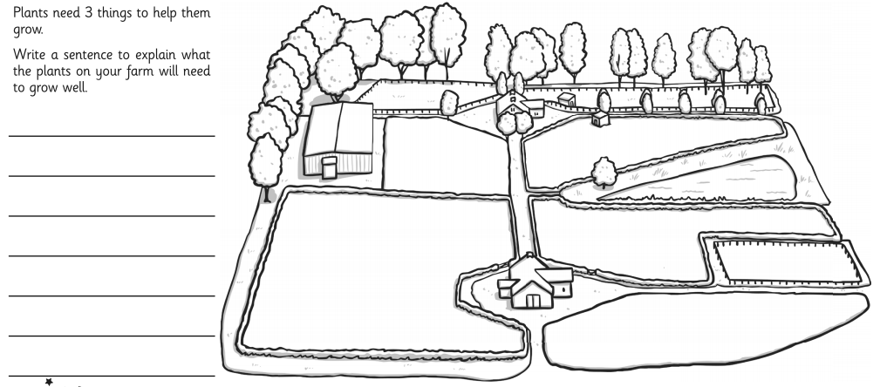

17.5.21
L.I: To use my observations to say what food crops will need to grow and stay healthy.
Steps to success:
*I can explain that different plants have different needs.
*I can give examples of food crops.
*I can say how to care for food crops so they grow well.
Farmers grow plants that we eat. Draw the plants that you would like to grow on your farm.
