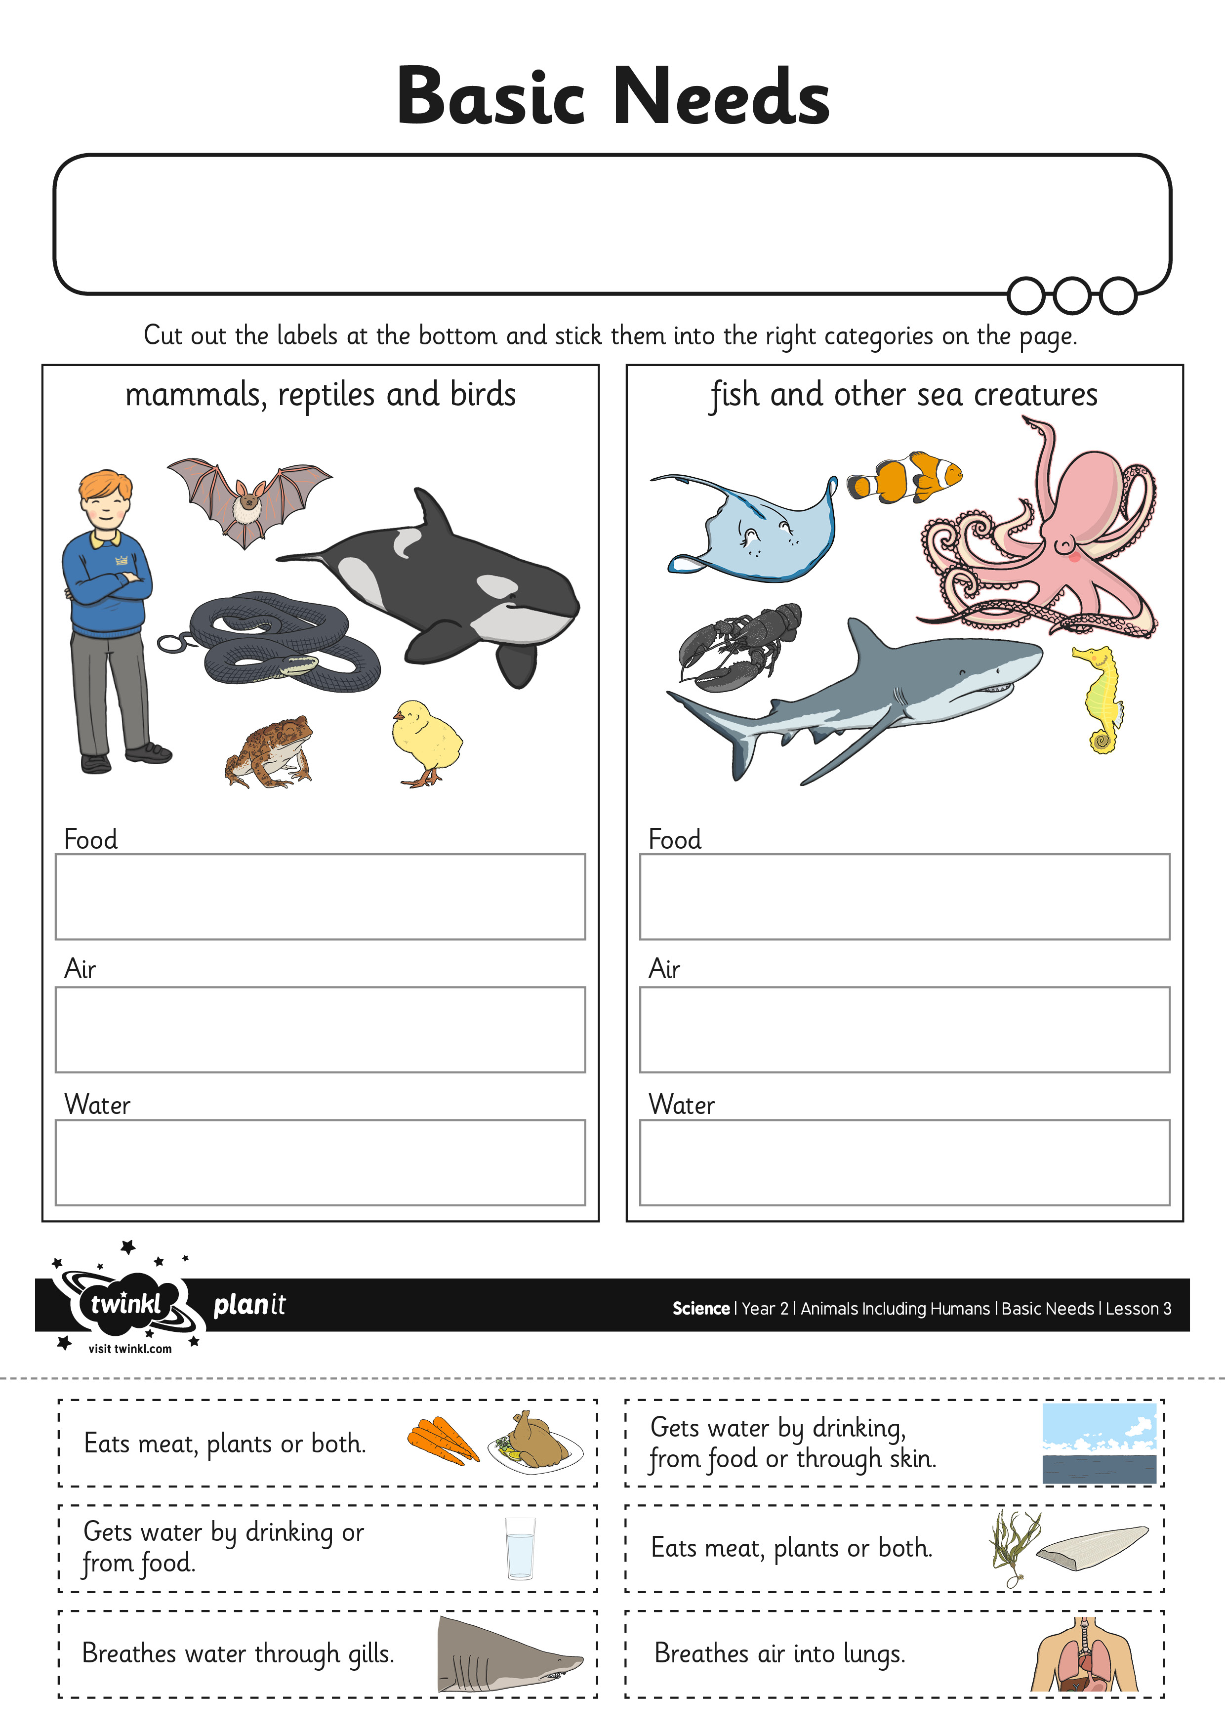
I can describe the basic needs of humans and other animals.

