Friday 16th October 2020
Book Talk- Enable
Blackbeard’s Ship
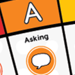 | Name three jobs pirates did on their ships?
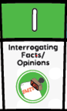 | What did the pirates find in their food?
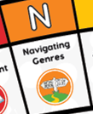 | How do you use a contents page?

