6.1.21

Maths Meeting

L.I:I can recognise and know the value of different dominations of coins and notes. (Band 1) Cut and stick

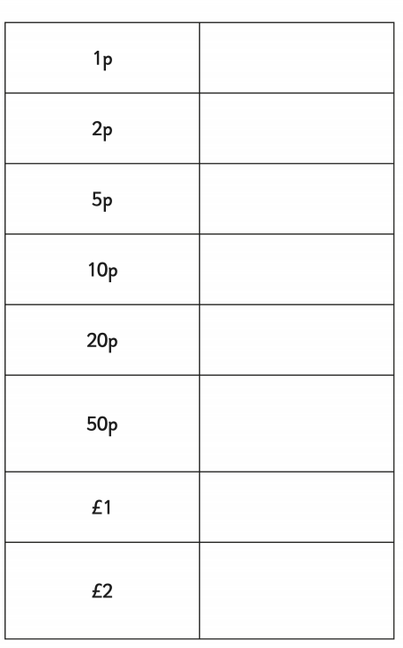

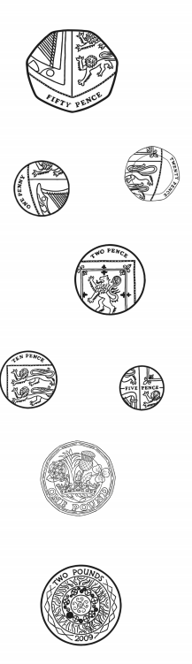 

Write the amounts below.

|  |  |  |  |
| --- | --- | --- | --- |
|  |  |  |  |
|  |  |  |  |

6.1.21

Maths Meeting

L.I: I can solve one step subtraction problems, including missing number problems, using objects and pictures. Band 1

|  |  |  |
| --- | --- | --- |
| You buy | You pay | Change |
|  |  |  |
|  |  |  |
|  |  |  |
|  |  |  |

6.1.21

Maths Meeting

L.I: I can [add and] subtract money and give change.

Band 2

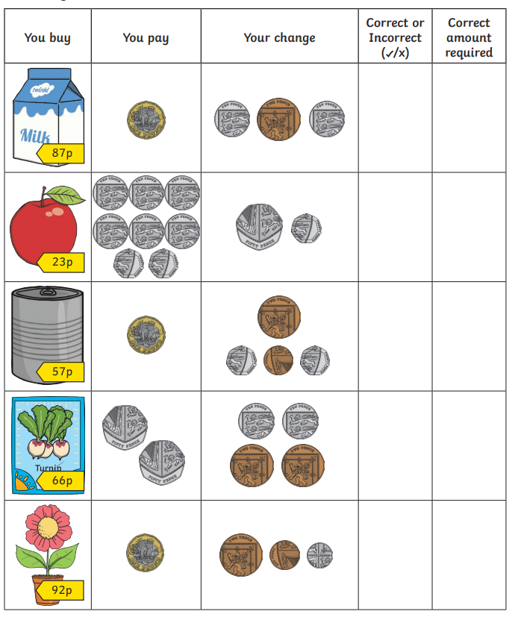

Challenge

Write the subtraction sums below

£1 - 87p =