5.1.21
Maths Meeting
L.I:I can recognise and know the value of different dominations of coins and notes. (Band 1)

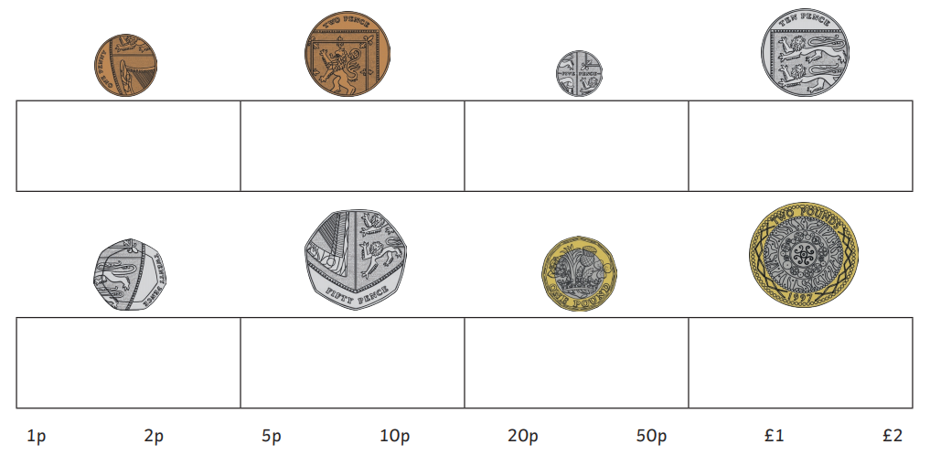

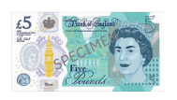

5.1.21
Maths Meeting
L.I: I solve one step addition problems, including missing number problems, using objects and pictures. Band 1

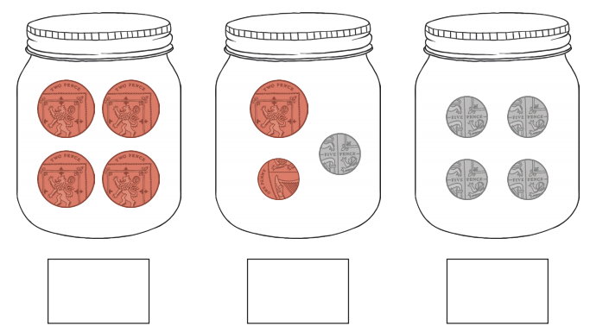

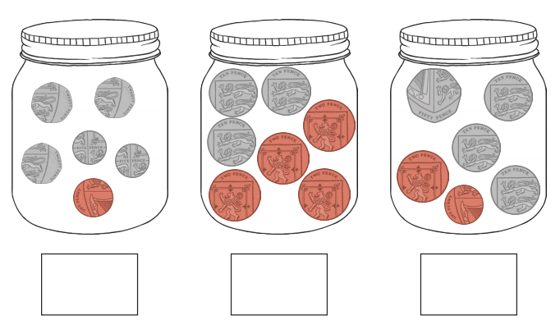
5.1.21
Maths Meeting
L.I: I can find different ways for coins to add up to an amount. Band 2

