Maths  Mon-Fri  Should be done in order | Daily counting from any number forwards and backwards. Counting in 2’s, 5’s and 10’s Practise writing numbers 1-20 in words.
 | Monday  Positional Language  Read through the prepositions powerpoint.  Activity: Where is the cat?  Activity: Preposition listening sheet. | Tuesday  Following Instructions  Read through the powerpoint.  Activity: Following instructions shape position. | Wednesday  Giving and following directions.  Read through the powerpoint to solve the activity.  Activity: giving and following instructions. | Thursday  Problem solving  Activity: I can solve problems involving direction. | Friday  Problem Solving  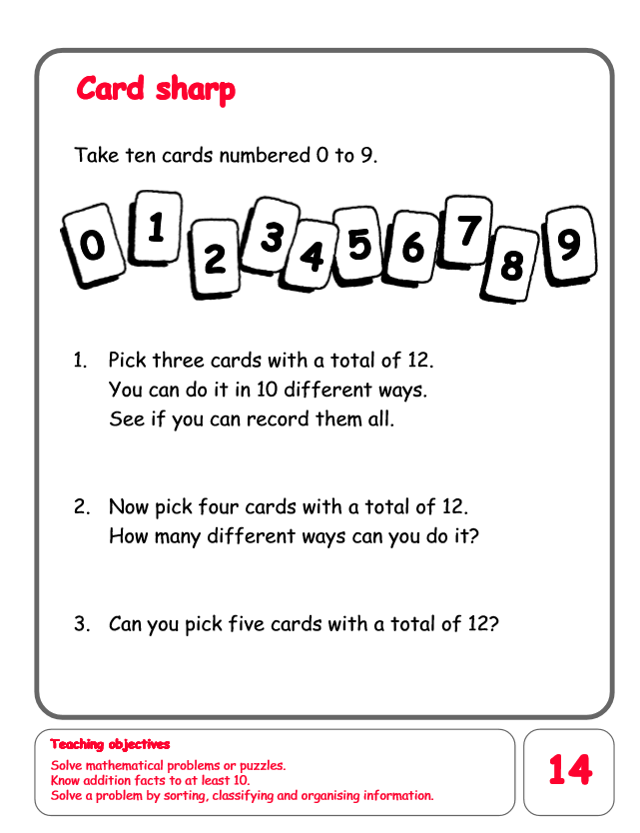
English  Mon-Fri  Choose one-a-day. | Daily Reading, Phonics ( Practise Phase 3 and Phase 5 sounds) and spelling practice ( Spellings- Common exception words and the days of the week ) Phonics game 2DO task on Purple Mash
 | Tiger who came to tea.  https://www.youtube.com/watch?v=z9IPZR16fdY  Activity: Write a shopping list for Sophie’s mum so she can refill food her cupboard. | A day in the life of a cat.  Please read through the story.  Activity: To write about what you think a cat does during the day.  https://content.twinkl.co.uk/resource/bb/3a/t-t-2546771-a-day-in-the-life-of-a-cat-writing-activity-sheet-.pdf?__token__=exp=1591536839~acl=%2Fresource%2Fbb%2F3a%2Ft-t-2546771-a-day-in-the-life-of-a-cat-writing-activity-sheet-.pdf%2A~hmac=ac41364760fbae465a45e8c8bcb21fc14cc96637056f800ecd3fa9900195f8ae | Comprehension  Pirates – Please read through and answer the questions.  https://content.twinkl.co.uk/resource/a1/51/t-t-2548623-ks1-pirates-differentiated-reading-comprehension-activity-english_ver_5.pdf?__token__=exp=1591536599~acl=%2Fresource%2Fa1%2F51%2Ft-t-2548623-ks1-pirates-differentiated-reading-comprehension-activity-english_ver_5.pdf%2A~hmac=819f6d08ce85cb97789eaa197f2fd9a9a0f56d215674abc518e3ce5a1e50dd71 | Thursday and Friday  Rye Writers  Rye-Writers is best done on consecutive days. You can also choose when to do the 2 sessions could be on the same day, just do 2 curriculum subjects on the other day.  This week we would like you to read through the story powerpoint of Goldilocks and the Three Bears. Then create a comic strip to retell the story.
Curriculum  Choose one-a-day. | Science  Reptiles and amphibians  Read through the animal classification powerpoint.  Activity 1: To write three facts about reptiles and three facts about amphibians.  Activity 2: Scavenger Hunt. | Geography  Read through the continents and oceans powerpoint.  Activity: To name the continents and oceans on a map of the world. | ICT  Purple Mash 2Do Task –  Put yourself into the role of a Superhero. Show their thoughts and character in the speech bubble.  Purple Mash 2Do Task- How many different types of fish can your draw in the fish tank? | Art  Animal craft.  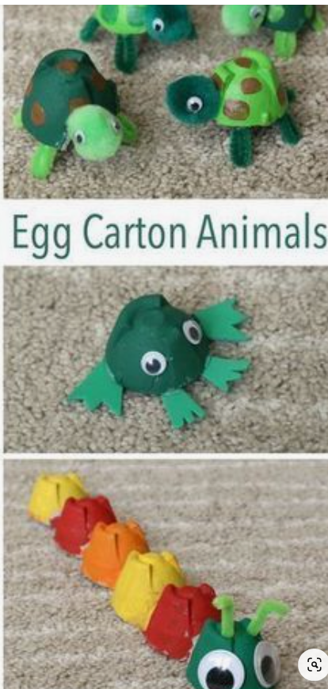  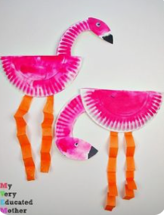 | STEM  Nature Wands  