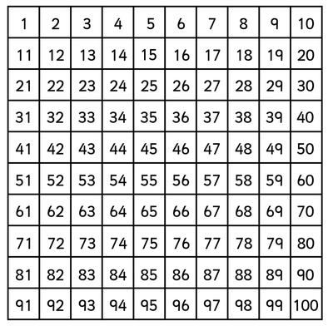

**44 – 10 = ______**

**34 – 10 = ______**

**24 – 10 = ______**

**44 + 10 = ______**

**54 + 10 = ______**

**64 + 10 = ______**

100 + 10 =

100 – 10 =