1.3.21
L.I. I can identify and group the uses of everyday materials.
L.I. I can record my observations.
S.C. I can explain what 3 different materials can be used for.
*I can group similar uses of materials together.
*I can make observations.
*I can record what I see to help me answer a question.
Keep a record of the uses of everyday materials by filling the table with your findings.
Material | Use
Wood 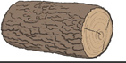 | Fence

