Maths  Mon-Fri  Should be done in order | Daily counting from any number forwards and backwards. Counting in 2’s, 5’s and 10’s Practising writing numbers 1-20 in words
 | Monday  Part-whole relationships number bonds  https://wrm-13b48.kxcdn.com/wp-content/uploads/2020/05/Y1-Lesson-1-Find-and-make-number-bonds-2019.pdf | Tuesday  Fact families - linking addition and subtraction  https://wrm-13b48.kxcdn.com/wp-content/uploads/2020/05/Y1-Lesson-2-Related-facts-2019.pdf | Wednesday  Add together and find a part  https://wrm-13b48.kxcdn.com/wp-content/uploads/2020/05/Y1-Lesson-3-Find-a-part-2019.pdf | Thursday  Add more and count on within 20 on  https://wrm-13b48.kxcdn.com/wp-content/uploads/2020/05/Y1-Lesson-4-Add-by-counting-on-2019.pdf | Friday  Problem Solving  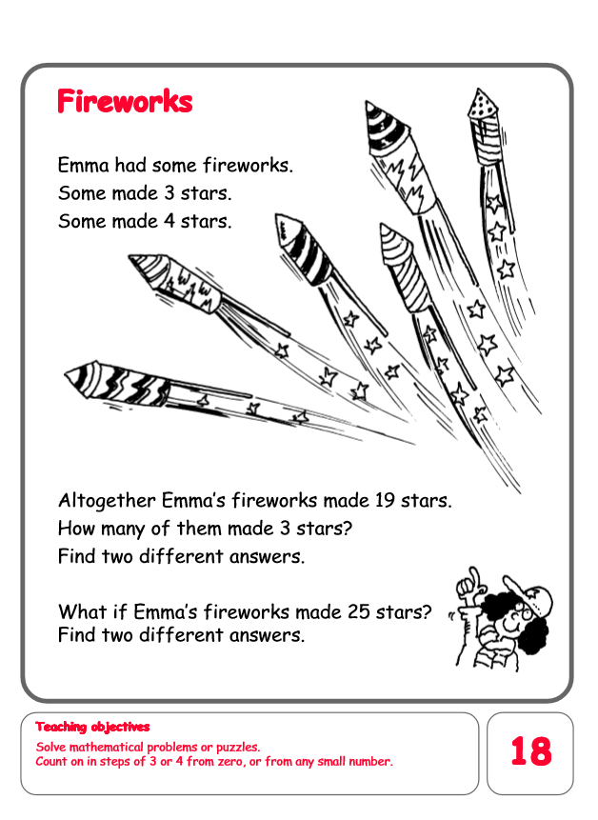
English  Mon-Fri  Choose one-a-day. | Daily Reading, Phonics ( Practise Phase 3 and Phase5 sounds) and spelling practice ( Spellings- Common exception words and the days of the week )
 | Write your own version of Jack and the Beanstalk changing the objects Jack takes from the giant’s castle.  For example a magic lamp or a duck who lays golden eggs. | Grammar, Punctuation and Spelling  Comparing and correcting suffixes.  Click on link below for activity. | Comprehension  Sunflower Plant Life Cycle  https://content.twinkl.co.uk/resource/be/a2/t-l-51705-sunflower-plant-life-cycle-differentiated-reading-comprehension-activity_ver_2.pdf?__token__=exp=1588346569~acl=%2Fresource%2Fbe%2Fa2%2Ft-l-51705-sunflower-plant-life-cycle-differentiated-reading-comprehension-activity_ver_2.pdf%2A~hmac=63a315fe457103e2e25a7d64b28b6be3ff0ef56d70d0caa87a8ed47ba111ef0a  Please read through the text and answer the questions. | Thursday and Friday  Rye Writers  Rye-Writers is best done on consecutive days. You can also choose when to do the 2 sessions could be on the same day, just do 2 curriculum subjects on the other day.  Will be uploaded on to Clownfish web page soon.
Curriculum  Choose one-a-day. | Science  To learn about the life cycle of a flowering plant.  Power point.  Activity: To draw the life cycle of a flowering plant.  Activity: To go on a flower hunt.  https://content.twinkl.co.uk/resource/3c/44/t-t-1103-plants-and-flowers-hunt-sheet-_ver_5.pdf?__token__=exp=1588763022~acl=%2Fresource%2F3c%2F44%2Ft-t-1103-plants-and-flowers-hunt-sheet-_ver_5.pdf%2A~hmac=7ea19cce1457070ceee5fa472064a25ff235cf8b2e60a0e14ff092888f848bd5 | Geography / History  To draw a simple map of Rye and construct a simple key for it. | ICT  Purple Mash – Coding Princess and the Frog. Make your own fairy-tale with the princess and the frog.  PSHE  Purple Mash – My Friend  Describe the personality and appearance of one of your friends. | Art  Make a model insect.  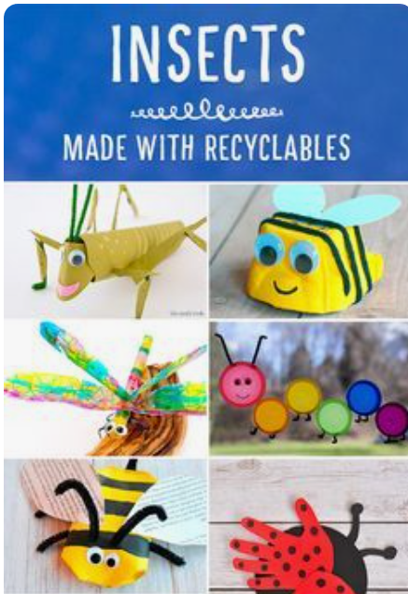 | STEM  Collect natural materials to make a picture.  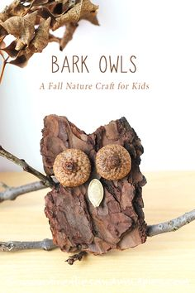  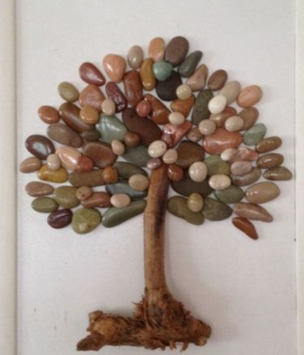  Tree rubbings  Take some paper and crayons and look at the different types of bark rubbings.

