Year 6, Term 6, Week 4 Suggested Timetable – ‘Darwin’s Delights!’
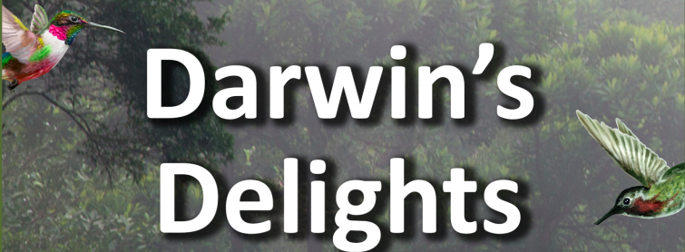
 | Monday | Tuesday | Wednesday | Thursday | Friday
Maths  Online maths games:  NRich  Playground  2048  https://www.kidsmathgamesonline.com  TT Rockstars | This week for maths we will be working through this booklet, with a set number of pages each day. (Answers booklet)
 | Long Multiplication  Pages 3-5  Youtube Explanation | Long division  Pages 6-8  Youtube Explanation | Long division with remainders  Pages 9-10  Youtube Explanation | Short division  Pages 11-12  Youtube Explanation | Mental Maths  Pages 13-15
English  Online Literacy Games:  ReadTheory  Crystal Explorers  Grammar Games  Woodlands  Reading Games | Reading  A week on the Galapagos Island – SPaG questions | Grammar/Punctuation  Prefixes/Suffixes  Page 2 | Spelling – 15 minutes  Practise the spellings (page 1) using the pyramid pattern that we have used in school before.  Log on to purplemash for the quiz. | Rye Writer! – 30-45 minutes a day.  This can be accessed from the Sharks Class webpage.  Thursday: Planning and Drafting  Friday: Improving and Publishing.  Send us your Rye Writer on ClassDojo
Topic  These can be completed in any order that you would like to try them in! | Computing  https://studio.code.org/s/express-2019/stage/1/puzzle/1  Use this site to continue to learn to code. Screenshot any animations you create and upload them to Dojo. | PSHE  We will be starting a sequence of transition lessons using resources specifically made for children entering into secondary schools.  This sequence of learning activities is highly recommended as it provides really important discussion points and advice for the children. | Geography  Conservation  Use digital conservation maps, websites and books to identify and list animal species that are at risk of extinction. Choose three animals from the list, including one each from the UK, a European region and North or South America. Find out what factors are endangering these species (human activity, habitat or climate change?) Create a poster to inform others about the factors that are endangering the three species. Write captions that explain the importance of the species to the world as a whole.  Note  The World Wildlife Fund website has a species directory that lists the conservation status of each animal. Even before humans were a factor, endangerment and extinction was caused by natural factors, including overspecialisation, competition, sudden climatic change and catastrophic events like volcanic eruptions and earthquakes. | Science  Inheritance  Find out about the monk and scientist, Gregor Mendel (1822–1884), whose research using thousands of pea plants informed his theory of inheritance and supported Darwin’s theory of evolution. Set up a simple test to explore the differences in Darwin’s and Mendel’s ideas on inheritance. Test Darwin’s theory by mixing yellow paint and blue paint in a bowl to make green paint. Discuss how, if yellow is one parent and blue is another, all offspring would be green. Test Mendel’s theory by mixing yellow and blue beads in a bowl. Discuss how if each colour was the parent, offspring will be either yellow or blue, not green. Work together to discuss the key differences in the two theories. Consider your own inheritance and identify any obvious characteristics that they have inherited from parents or grandparents, and how they are similar or different to a sibling if you have one. Use this inheritance sheet to help you record.  Note  Darwin believed that traits blend when inherited, so a tall person and a small person would have a medium-sized child. However, Mendel discovered that traits were inheritable due to ‘particles’, which we now know as genes. Genetic inheritance is not quite as simple as the test in this activity, but children are not required to understand the intricacies in any greater depth at this stage. | Art/IT  Create your own Bitmoji!  Create your own personal emoji as an expressive cartoon avatar. Upload your favourite one to Dojo.

 | Previous week’s learning tasks – Week beginning: Monday 8th June 2020
Geography | Galápagos Tourism Leaflet  Plan an expedition across the Galápagos Islands that will help tourists take in the incredible sights and sounds. Use a range of materials, including online tourism sites to find out about travelling between islands, typical weather conditions, the range of physical and man-made landmarks and features, the local currency, the official language and the best places to stay.  Draw a detailed sketch map of the route, labelling places tourists plan to stop and stay. Make a list of things they would need to take, including clothing that would be suitable for the climatic conditions and physical terrain.
Science | Galápagos Creatures  Chose an animal found on the Galápagos Islands, such as the marine iguana, blue-footed booby, giant tortoise, Galápagos penguin, frigatebird or lava lizard. Consider what features show that the animal has adapted and evolved to suit its environment. Write a short report or presentation, possibly using ICT, to explain your thoughts and ideas.  Note  The blue-footed booby has a sleeker beak and head for a more streamlined shape, which enables it to dive deep into the water to catch fish. Its blue feet help attract a healthy mate.
Science | Science Investigation - Beaks  Investigate how a bird’s beak is adapted to eat specific foods. Fill a series of trays with seeds of varying size and shape, such as sunflower, dried peas, pumpkin, lentils, sesame and poppy seeds. Use pegs, tweezers and chopsticks as beaks to pick up as many seeds from each tray as possible. Record how many they collect with each ‘beak’ and display results graphically. Explain which seeds you collected easily and talk about why and how it relates to bird beak adaptations.  Note  Predict which ‘beak’ will be most suitable for collecting the different seeds. Darwin observed and preserved many finches during his time on the Galápagos Islands. It wasn’t until he returned to England and gave them to an ornithological expert that he found the birds were 13 different species, all evolved from a single ancestor. Each species evolved a different type of beak in order to feed on different things. The evolution of beak shape and size was essential for their survival.
Art | Sketching Outdoors  Work outdoors to sketch plants, flowers and trees, looking carefully to accurately capture their shape, form, pattern and colour. Work in coloured pencil and if available use a hand lens or microscope to examine very fine details. Head back indoors and compare the range of plant and flower species you have drawn.

