Year 6, Term 6, Week 3 Suggested Timetable – ‘Darwin’s Delights!’
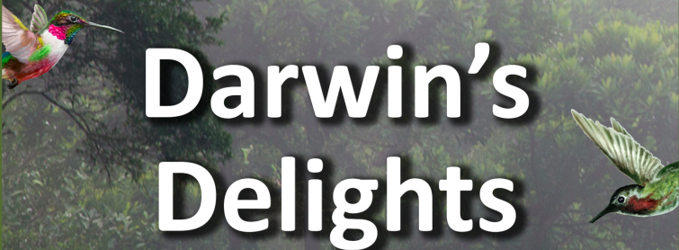
 | Monday | Tuesday | Wednesday | Thursday | Friday
Maths

Online maths games:
NRich
Playground
2048
https://www.kidsmathgamesonline.com
TT Rockstars
 | Algebra  Formulae  Powerpoint explanation  Worksheet (Choose 1) | Algebra  Forming Equations  Powerpoint explanation  Worksheet (Choose 1) | Algebra  One Step Equations  Powerpoint explanation  Worksheet (Choose 1) | Algebra  Two Step Equations  Powerpoint explanation  Worksheet (Choose 1) | Algebra  Find pairs of values  Powerpoint explanation  Worksheet (Choose 1)
English  Online Literacy Games:  ReadTheory  Crystal Explorers  Grammar Games  Woodlands  Reading Games | Reading  A week on the Galapagos Island – Vocab 2 questions | Grammar/Punctuation  Word Classes 2 Consolidation  BBC Bitesize Guides for Grammar https://www.bbc.co.uk/bitesize/topics/zwwp8mn | Spelling – 15 minutes  Practise the spellings using the pyramid pattern that we have used in school before.  Log on to purplemash for the quiz. | Rye Writer! – 30-45 minutes a day.  This can be accessed from the Sharks Class webpage.  Thursday: Planning and Drafting  Friday: Improving and Publishing.  Send us your Rye Writer on ClassDojo
Topic  These can be completed in any order that you would like to try them in! | Computing  https://studio.code.org/s/express-2019/stage/1/puzzle/1  Use this site to continue to learn to code. Screenshot any animations you create and upload them to Dojo. | History  Mary Anning  Use books and the web to find out about the British fossil collector and palaeontologist, Mary Anning. Locate the area where she carried out her work on a map and find out why it has such a wealth of fossils.  Create a simple biography for Mary Anning. | Science  Darwin’s Investigations  Use the web and non-fiction books to research the wide range of investigations that Darwin did at Down House, often with his children’s help. Choose one of Darwin’s investigations. Plan and carry out your own version of the investigation. Share results with the class on ClassDojo and explain what you did and whether they achieved the same result as Darwin.  Note  Investigations included mapping the routes of bumblebees, how plants respond to light, growing seeds crushed and soaked in lemon juice (to mimic the effect of digestion on seeds eaten by birds), playing music and sounds to worms to see how they respond and mapping the positioning of spider webs. | Science  Bird Observation  Explore your local area to find and take photos of feral pigeons. Print or find photos and use them to discuss and make notes on how the pigeons vary in colour, pattern and beak size and shape. Are their feet and legs scaly, feathery or webbed? Are they thin, tall, fat or short? Are their tails fanned or do they stick up? Record data using diagrams and labels. Consider where variation in pigeons comes from (inherited) and how it affects their survival. Group pigeons by their physical characteristics or put them into family groups. Explain your choices and decisions. | Art & Design  Shells  Use fine ink pens to make detailed drawings in your sketch book of different types of shells, including barnacle shells. Use a hand lens or a digital microscope to observe fine details of the shell, including its many lines and shapes. Apply a colourwash to your drawings to add shadow and tone and then label them with the name of the shell or animal that lived in it.  Note  Darwin loved to collect shells that he found on the coast, particularly barnacle shells, which fascinated him! Why not see if you can find one out on a walk?

 | Previous week’s learning tasks – Week beginning: Monday 8th June 2020
Geography | Galápagos Tourism Leaflet  Plan an expedition across the Galápagos Islands that will help tourists take in the incredible sights and sounds. Use a range of materials, including online tourism sites to find out about travelling between islands, typical weather conditions, the range of physical and man-made landmarks and features, the local currency, the official language and the best places to stay.  Draw a detailed sketch map of the route, labelling places tourists plan to stop and stay. Make a list of things they would need to take, including clothing that would be suitable for the climatic conditions and physical terrain.
Science | Galápagos Creatures  Chose an animal found on the Galápagos Islands, such as the marine iguana, blue-footed booby, giant tortoise, Galápagos penguin, frigatebird or lava lizard. Consider what features show that the animal has adapted and evolved to suit its environment. Write a short report or presentation, possibly using ICT, to explain your thoughts and ideas.  Note  The blue-footed booby has a sleeker beak and head for a more streamlined shape, which enables it to dive deep into the water to catch fish. Its blue feet help attract a healthy mate.
Science | Science Investigation - Beaks  Investigate how a bird’s beak is adapted to eat specific foods. Fill a series of trays with seeds of varying size and shape, such as sunflower, dried peas, pumpkin, lentils, sesame and poppy seeds. Use pegs, tweezers and chopsticks as beaks to pick up as many seeds from each tray as possible. Record how many they collect with each ‘beak’ and display results graphically. Explain which seeds you collected easily and talk about why and how it relates to bird beak adaptations.  Note  Predict which ‘beak’ will be most suitable for collecting the different seeds. Darwin observed and preserved many finches during his time on the Galápagos Islands. It wasn’t until he returned to England and gave them to an ornithological expert that he found the birds were 13 different species, all evolved from a single ancestor. Each species evolved a different type of beak in order to feed on different things. The evolution of beak shape and size was essential for their survival.
Art | Sketching Outdoors  Work outdoors to sketch plants, flowers and trees, looking carefully to accurately capture their shape, form, pattern and colour. Work in coloured pencil and if available use a hand lens or microscope to examine very fine details. Head back indoors and compare the range of plant and flower species you have drawn.

