Year 6, Term 6, Week 1 Suggested Timetable – ‘Darwin’s Delights!’
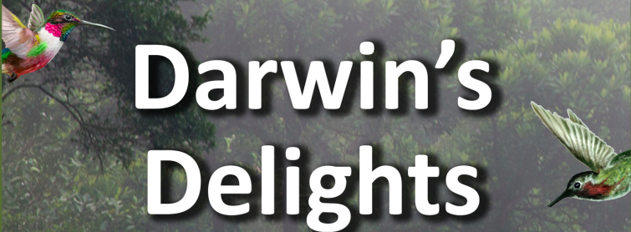
 | Monday | Tuesday | Wednesday |  | Thursday | Friday
Maths | TT Rockstars 10 mins | 2048 – 10 mins | TT Rockstars 10 mins |  | 10 mins Online maths game:  https://www.kidsmathgamesonline.com | TT Rockstars 10 mins
 | Algebra  Solving Equations  Powerpoint explanation  Worksheet (Choose 1) | Algebra  Find a rule one step  Powerpoint explanation  Worksheet (Choose 1) | Algebra  Find a rule two step  Powerpoint explanation  Worksheet (Choose 1) |  | Algebra  Expressions  Powerpoint explanation  Worksheet (Choose 1) | Algebra  Substitutions  Powerpoint explanation  Worksheet (Choose 1)
English Grammar, Spelling and Punctuation | BBC bitesize GPS game.  Crystal Explorers  Try this exciting game and use your previously learnt GPS skills. | Grammar  GPS pack – consolidating word classes page 2 | Spelling – 15 minutes  Spelling ToDo on purplemash  Practise Sheet |  | Grammar  GPS pack - GPS pack – consolidating word classes page 3 | Spelling – 15 minutes  Spelling ToDo on purplemash
English Writing | Write a diary entry as Charles Darwin  Full details and resources here. |  |  | Rye Writer! – 30-45 minutes a day.  This can be accessed from the Sharks Class webpage.
Reading | 30 minutes a day  Free reading choice from home.  Reading challenge: Ask a parent to seesaw read your book with you and time how long you can do this for! Send me your time. Seesaw reading is when you read a page and then your parent reads a page. | A week on the Galapagos Islands – page 4 & 5 questions | 30 minutes a day  Take ReadTheory quizzes.  Please email if you need your login sent out again. |  | A week on the Galapagos Islands – Vocab 1 questions | 30 minutes a day  Free reading choice from home.  Reading challenge: Ask a parent to seesaw read your book with you and time how long you can do this for! Send me your time. Seesaw reading is when you read a page and then your parent reads a page.
Topic theme: “Darwin’s Delights”  These can be completed in any order that you would like to try them in! | Computing  https://studio.code.org/s/express-2019/stage/1/puzzle/1  Use this site to start to continue to learn to code. Screenshot any animations you create and upload them to Dojo. | Galápagos Tourism Leaflet  Plan an expedition across the Galápagos Islands that will help tourists take in the incredible sights and sounds. Use a range of materials, including online tourism sites to find out about travelling between islands, typical weather conditions, the range of physical and man-made landmarks and features, the local currency, the official language and the best places to stay.  Draw a detailed sketch map of the route, labelling places tourists plan to stop and stay. Make a list of things they would need to take, including clothing that would be suitable for the climatic conditions and physical terrain. | Science Investigation - Beaks  Investigate how a bird’s beak is adapted to eat specific foods. Fill a series of trays with seeds of varying size and shape, such as sunflower, dried peas, pumpkin, lentils, sesame and poppy seeds. Use pegs, tweezers and chopsticks as beaks to pick up as many seeds from each tray as possible. Record how many they collect with each ‘beak’ and display results graphically. Explain which seeds you collected easily and talk about why and how it relates to bird beak adaptations.  Note  Predict which ‘beak’ will be most suitable for collecting the different seeds. Darwin observed and preserved many finches during his time on the Galápagos Islands. It wasn’t until he returned to England and gave them to an ornithological expert that he found the birds were 13 different species, all evolved from a single ancestor. Each species evolved a different type of beak in order to feed on different things. The evolution of beak shape and size was essential for their survival. |  | Galápagos Creatures  Chose an animal found on the Galápagos Islands, such as the marine iguana, blue-footed booby, giant tortoise, Galápagos penguin, frigatebird or lava lizard. Consider what features show that the animal has adapted and evolved to suit its environment. Write a short report or presentation, possibly using ICT, to explain your thoughts and ideas.  Note  The blue-footed booby has a sleeker beak and head for a more streamlined shape, which enables it to dive deep into the water to catch fish. Its blue feet help attract a healthy mate. | Sketching Outdoors  Work outdoors to sketch plants, flowers and trees, looking carefully to accurately capture their shape, form, pattern and colour. Work in coloured pencil and if available use a hand lens or microscope to examine very fine details. Head back indoors and compare the range of plant and flower species you have drawn.

