Year 6 – Term 5 – Week 5 Suggested Timetable
Hola Mexico – Theme: More Mexico!
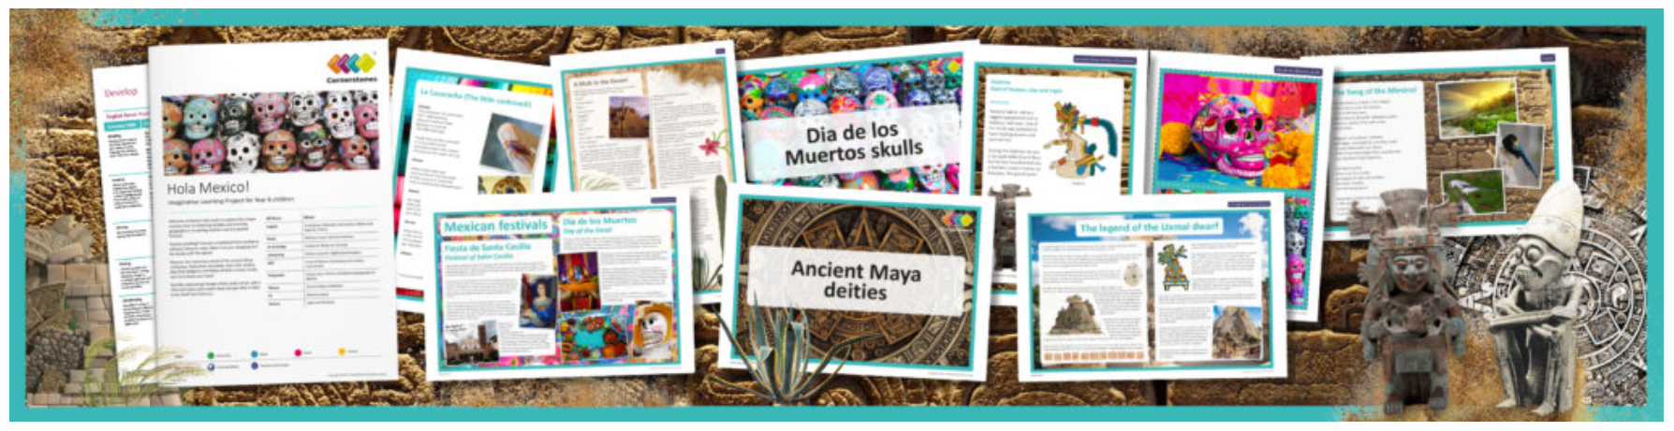
 | Tuesday | Wednesday | Thursday | Friday
Maths | Constructing Line Graphs  Powerpoint explanation  Worksheet (Choose one set of questions). | Problem solving with Line Graphs  Powerpoint explanation  Worksheet (Choose one set of questions). | Working with the mean average  Powerpoint explanation  Worksheet (Choose one set of questions). | Problem solving with mean  Powerpoint explanation  Worksheet (Choose one set of questions).
Mean Game!
(extension for Thurs or Fri)
English Grammar, Spelling and Punctuation | Grammar  Revision – Active and Passive  Work through the videos and activities on the BBC bitesize link.  https://www.bbc.co.uk/bitesize/articles/zbngrj6 | Spelling  For this week’s spelling rule, you will need to be able to identify different types of nouns. Using this poster, write a list of your own nouns for each type. | Spelling  Look, say, cover, write. | Spelling  Purplemash spelling  ToDo.
English Writing | Rye Writer  This week, Miss Brunton has requested that we give you more time to complete the Summer writing Competition as detailed on the class website.  We can’t wait to read more of your entries. The deadline for this competition is  Thursday 21st May | Pobble365 Writing Project – 45 minutes a day.  https://www.pobble365.com/teapots/  Using this illustration and story starter as an inspiration, develop a narrative that uses detailed setting descriptions and character relationships. Who will you write this story for?
Reading | 30 minutes a day  Visit the lost cities of Ancient Maya Challenge  Section A only | 30 minutes a day  Buster’s Book Club Challenge – Send us your minutes through ClassDojo to be sent to Miss Brunton for the competition.  Free reading choice from home. | 30 minutes a day  Take ReadTheory quizzes.  Please email if you need your login sent out again. | 30 minutes a day  Free reading choice from home.
Topic theme: The Ancient Maya  These can be completed in any order that you would like to try them in! | Computing and Science  Find out about El Castillo, a pyramid shaped temple in the centre of Chichén Itzá. During the spring and autumn equinox, the sun casts a series of triangular shadows, which creates an illusion the Maya described as a feathered serpent crawling down the pyramid. Observe a range of shadows and identify the objects that create them. Discuss why shadows are the shape they are.  Using the sun or a bright torch, conduct an investigation to explore patterns in the size and shape of an object’s shadow, recording results in a spreadsheet. | Music  Learn the traditional Mexican song the La Cucaracha, using Spanish lyrics where possible. Use a lyric sheet to learn and practice, covering up lines and saying aloud to learn and check. Challenge yourself to learn the lyrics to the whole song. | Geography  Use world maps and satellite images to locate Mexico, identifying which hemisphere it is in and the countries that surround it. Once found, draw a sketch map of the country, showing aspects of its human and physical geography, including major cities, surrounding seas, mountain ranges, airports, and tourist resorts.  A blank map of Mexico is attached for you. | Art  Create your own portrait in the style of Kahlo.  https://artsycraftsymom.com/frida-kahlo-art-projects-for-kids/

