Year 6 – Term 5 – Week 2 Suggested Timetable
Hola Mexico – Theme: The Ancient Maya
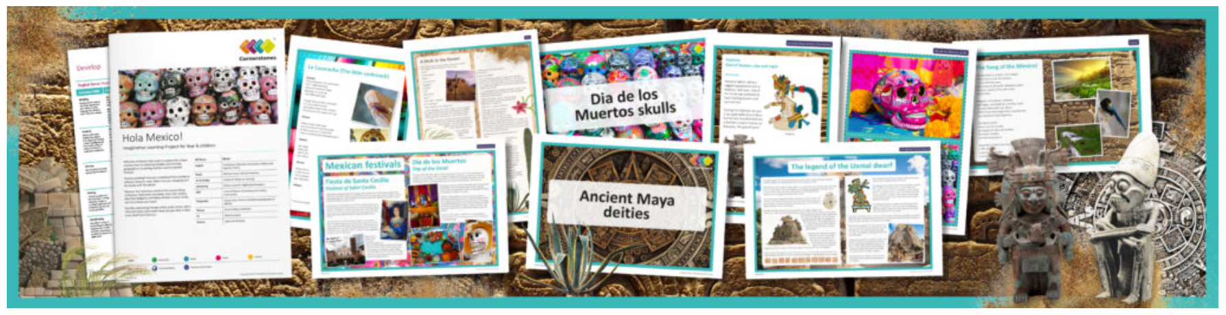
 | Monday | Tuesday | Wednesday | Thursday | Friday
Maths | As this would be SATs week, we thought that instead we would set you the following three ‘alternative SATs’ to do today!  Maths alternative SAT paper  Grammar alternative SAT paper  Reading alternative SAT paper | 2048 – 10 mins | TT Rockstars 10 mins | 10 mins Online maths game:  https://www.kidsmathgamesonline.com | TT Rockstars 10 mins
 |  | CGP Book pg76-77 - coordinates | CGP Book pg78-79 - translation | CGP Book pg80-81 Mixed practise | CGP Book pg82-83 - pictograms
 |  | If you have been following the maths timetable we have been setting, you will have pretty much finished your CGP book by the end of the week. If you have already done this, this second maths row is supplementary work which you could work through.
 |  | Supplementary work:  Nets of shapes -explanation powerpoint.  Nets of shapes - worksheets |  | Supplementary work:  Consolidation pack on the  properties of shape.
English Grammar, Spelling and Punctuation |  | BBC bitesize GPS game.  Crystal Explorers  Try this exciting game and use your previously learnt GPS skills. | Spelling – 15 minutes  Spelling ToDo on purplemash | Grammar – 15 minutes  Cohesion across paragraphs – Purple Mash activity:  ‘In the beginning’ | Spelling – 15 minutes  Spelling ToDo on purplemash
English Writing |  | Following the link below, read and discover facts about the Maya Gods and Godesses. Use information you have read to create a non-chronological report. Please practise your handwriting and publish this by hand over 2 days.  https://www.dkfindout.com/uk/history/mayans/mayan-gods/ |  | Rye Writer! – 30-45 minutes a day.  “The Virtual School Mystery Story Writing Competition!”  Once you have written your story, if you wish to enter the competition, email your story to your teacher.
Reading |  | 30 minutes a day  Visit the lost cities of Ancient Maya  Section A & B only | 30 minutes a day  Free reading choice from home.  Reading challenge: Ask a parent to seesaw read your book with you and time how long you can do this for! Send me your time. Seesaw reading is when you read a page and then your parent reads a page. | 30 minutes a day  Take ReadTheory quizzes.  Please email if you need your login sent out again. | 30 minutes a day  Free reading choice from home.  Reading challenge: Ask a parent to seesaw read your book with you and time how long you can do this for! Send me your time. Seesaw reading is when you read a page and then your parent reads a page.
Topic theme: The Ancient Maya  These can be completed in any order that you would like to try them in! |  | French  Days of the week. | Purple Mash  We have set you a number of purple mash ToDos which support the curriculum areas we are studying. Use this afternoon to ‘catch up’ on them.  Please message on Dojo if you need your login sent out again | Computing  https://studio.code.org/s/express-2019/stage/1/puzzle/1  Use this site to start to learn to code. Screenshot any animations you create and upload them to Dojo. | Art  Choose a project from this website. Remember to take pictures and upload them to your Dojo portfolio!  (We will be running this as the weekly art activity for a few weeks so you will get a chance to do more than one activity).

