[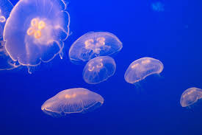](http://www.google.co.uk/url?sa=i&rct=j&q=jellyfish&source=images&cd=&cad=rja&uact=8&docid=IBaKnB09cHnGzM&tbnid=xuvOkBcpWPFGoM:&ved=0CAcQjRw&url=http://blogs.discovermagazine.com/d-brief/2014/04/10/eco-friendly-diapers-made-from-jellyfish/&ei=kCMcVNX8ErHQ7Ab88oDYCA&psig=AFQjCNH6odxuA6YisQrWmwEOEOnRF9AvMQ&ust=1411216645952889)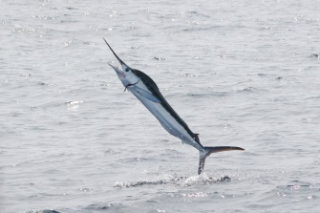

March 2020

Dear parents, carers and guardians,

You have informed us you are self-isolating your child. Please find attached a pack of English, maths, science and topic resources and ideas to home-school your child.

This work is set for all children who are well enough to continue their learning. The pack contains enough work for the duration of their absence.

Thank you for your support.

Kind regards,

Mr Thomas and Miss Brunton

Jellyfish and Marlin’s Teachers

**English:**

**Reading**

Please listen to your child read for at least 20 minutes each day. As this time also allows for talking about the text you will find additional ideas for discussion in this pack along with VIPERS talking-points which have been sent home previously.

**Spellings:**

Below are the common exception words for year 2. These can be used for spelling practise and also handwriting. This should be a 20 minute daily activity. Your child might look for these words in their reading.

Check that all words can be read, and break them down into smaller groups to learn. Leave out the words that your child knows and focus on the ones they find trickier.

|  |  |  |  |  |  |
| --- | --- | --- | --- | --- | --- |
| Statutory Year 3 and 4 Spellings | | | | | |
| accident  accidentally  actual  actually  address  answer  appear  arrive  believe  bicycle  breath  breathe  build  busy  business  calendar  caught  centre | century  certain  circle  complete  consider  continue  decide  describe  different  difficult  disappear  early  earth  eight  eighth  enough  exercise  experience | experiment  extreme  famous  favourite  February  forward(s)  fruit  grammar  group  guard  guide  heard  heart  height  history  imagine  increase  important | interest  island  knowledge  learn  length  library  material  medicine  mention  minute  natural  naughty  notice  occasion  occasionally  often  opposite  ordinary | particular  peculiar  perhaps  popular  position  possess  possession  possible  potatoes  pressure  probably  promise  purpose  quarter  question  recent  regular  reign | remember  sentence  separate  special  straight  strange  strength  suppose  surprise  therefore  though  although  thought  through  various  weight  woman  women |

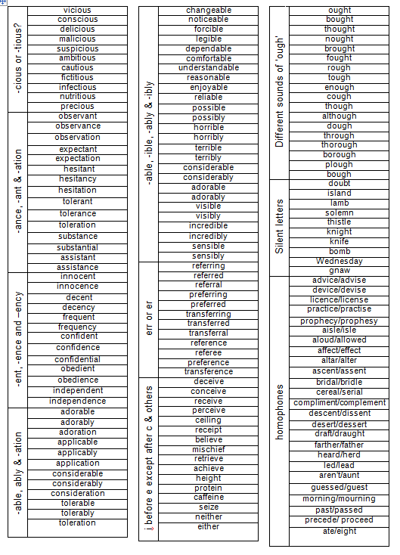

**writing:**

Spy Story.- 45 minutes a day

We have been busy writing spy stories this term. Use the plan over the page to plan your own spy thriller story. This could be the **sequel** to the first story that you wrote, or a completely different narrative. Could you include a spy gadget in your story? You need an introduction, a setting description, a build-up to the plot, the main event, and a resolution and ending.

**Remember:**

* Short, snappy sentences
* Describe your setting.
* Expanded noun phrases
* Paragraphs to separate your ideas.

When they’ve finished the plan, they should write the story neatly and check their capital letters, full-stops and spelling again.

**Grammar, Punctuation and Spelling**

Editing the story.

Your child should read and check their punctuation and spellings in their spy story.

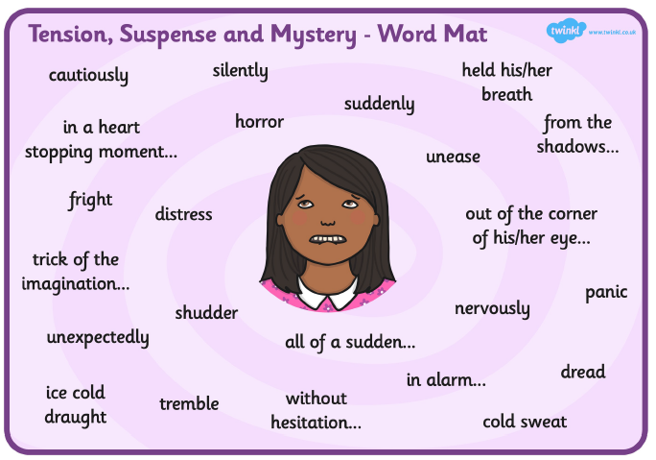We have recently been learning about using **dashes, commas** and **brackets** to show parenthesis. Can you try and include examples of this too?

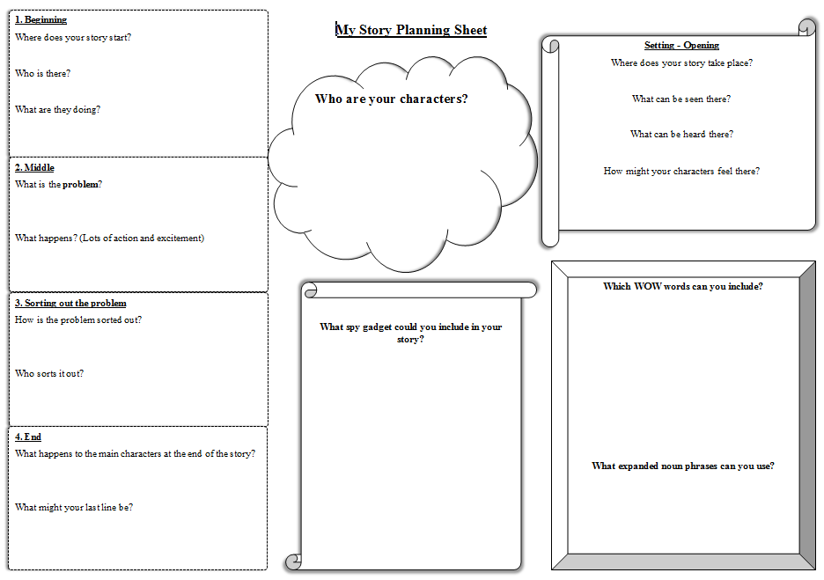

Maths

TT Rockstars – at least 20 minutes a day.

All Year 5 children have a login for ‘Times Table Rockstars. Additional log-in details have been sent home with the children.

You will find, in the four attached PDF files, a range of four operation activity sheets based on addition, subtraction, multiplication and division. Please encourage your child to try a page a day, writing their answers in the exercise book provided. Answers are attached to the questions to help you self-mark. A knowledge organiser is also attached to assist both you and your child to tackle the questions.

Science:

This term’s science topic is Properties and Change of materials. We have been learning about materials and how their qualities are used in different ways in everyday life.

* Have a go at carrying out an investigation by making your own slime.

**Topic**

Tomorrow’s World

Design and build your own spy gadget that you could use. This gadget needs to be designed for use by a secret agent and should be able to help them in their missions.

You could use the following household items:

* Toilet/kitchen roll tubes
* Cardboard boxes
* Yoghurt pots
* Leftover plastic
* Empty containers
* Bottles

If you can, take photos of your gadget and the process in making this. In your exercise book, describe and label your gadget. What does it do? What is it made from?

