Maths  Mon-Fri  Should be done in order | Daily times tables practise: see TT Rockstars – our battle FINISHES against Dolphins this week!
 | Monday  Multiplying fractions  (*Multiply the numerators, and then multiply the denominators*)  Challenge = simplify the answer if you can.  Use the poster to help. | Tuesday  Multiplying fractions  Finish your task from yesterday.  Create a fraction wall (make it colourful if you can!). | Wednesday  Multiplying fractions  Multiplying a fraction by a whole number.  Use the poster to help you and give you an example. | Thursday  Multiplying fractions  Continue your task from yesterday.  Can you try the word problems at the bottom?  Challenge = Create your own using a fraction and a whole number! |  |  | Friday  Roman Numerals  Roman Numerals activity.  TT Rockstars test.
English  Mon-Fri  Choose one-a-day.  Rye-Writers is best done on consecutive days. You can also choose to do the 2 sessions could be on the same day, just do 2 curriculum subjects on the other day. | Daily Reading (20 mins+ of a text of your choice) and spelling practice (Year 5 and 6 statutory words)
 | Rye Writers: A Mysterious Adventure  Using the photo (on Class Dojo and on the Rye Writers section of our webpage).  Where could this mysterious, woodland pathway take you? What might you find along the way? Where could it lead? What problems might you encounter? Create an adventure story, imagining your journey began here, at the start of the path.  There is a story mountain for you to plan your story (first day), a fantasy word mat and a setting word mat with lots of adventurous vocabulary that you could use. |  |  |  |  | Comprehension  Day 1 – Read through Planet Earth comprehension. Choose the one that is right for you.  Day 2 & 3 – Answer questions.  Can you create your own questions using the text?  Make sure you have checked the definition of any unknown words. |  | Grammar, Punctuation and Spelling  Expanded Noun Phrases
Curriculum  Choose one-a-day. | Science  Food Chains:  Recap: watch the videos below to remind yourself about Food Chains.  https://www.bbc.co.uk/bitesize/topics/zk7h34j/articles/z4jpnrd  Choose between 1 of the tasks, or feel free to complete them all!  Sorting task: sort out the different types of animals in the food chain. Cut out the cards and create different chains!  Worksheet: Fill in the gaps on the activity sheet, or write it straight into your book.  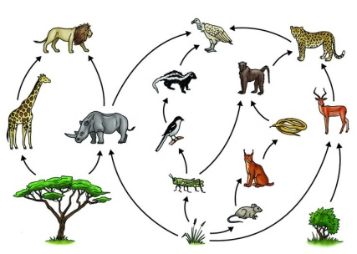  Practical: which food chains occur around you in our outside environment? |  |  |  | ICT  Purple Mash:  There are lots of tasks available for you to complete on Purple Mash.  Please see the ‘food’ tasks that have been set for this week. | Art  Detailed drawings:  Pick a part of a flowering plant. Carefully sketch your drawing, with close detail to the inside of the flower.  Option 2: Mindfulness colouring  Create your own detailed mindfulness colouring picture of a plant.  Option 3: Create a collage of the mindfulness colouring templates. |  | Practical  If you have access to a garden, can you:  - Make sure your plants are fed and watered.  - Weed your garden and get rid of any dead flowers.  Collect pebbles/stones and decorate them with different plant names. We could use these when we’re back at school in the allotment.

