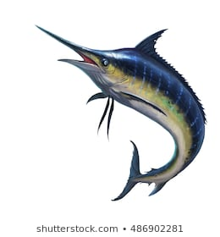
Marlin Home Learning: Easter Holidays
Week c/m 6.4.20 & c/m 13.4.20

Dear all,

Thank you for your wonderful hard work over the past two weeks. It has been brilliant to see your Rye Writers stories, Purple Mash tasks, pictures from home and/or just seeing your responses on our Dojo page!

Over the Easter holidays there is not an expectation that you have to complete all of these tasks – although very different to the past half terms and Easter break, it is still your holiday!

This work is here for you if you wish. It is still just as important to make sure that (if you can) you are getting some fresh air, staying safe and keeping up your positive attitudes.

Many thanks for your continued support,

Miss Brunton and Mrs Beeching

Spellings:
Below are the key spellings for year 3 and 4, as well as 5 and 6 words. These can be used for spelling practise and also handwriting. This should be a 20 minute daily activity. Your child might look for these words in their reading.
Check that all words can be read, and break them down into smaller groups to learn. Leave out the words that your child knows and focus on the ones they find trickier.
In class, we used to do a weekly spelling test where we would have to put all 10 words learnt that week into a paragraph linked to a theme. E.g. animals.

Statutory Year 3 and 4 Spellings
accident  accidentally  actual  actually  address  answer  appear  arrive  believe  bicycle  breath  breathe  build  busy  business  calendar  caught  centre | century  certain  circle  complete  consider  continue  decide  describe  different  difficult  disappear  early  earth  eight  eighth  enough  exercise  experience | experiment  extreme  famous  favourite  February  forward(s)  fruit  grammar  group  guard  guide  heard  heart  height  history  imagine  increase  important | interest  island  knowledge  learn  length  library  material  medicine  mention  minute  natural  naughty  notice  occasion  occasionally  often  opposite  ordinary | particular  peculiar  perhaps  popular  position  possess  possession  possible  potatoes  pressure  probably  promise  purpose  quarter  question  recent  regular  reign | remember  sentence  separate  special  straight  strange  strength  suppose  surprise  therefore  though  although  thought  through  various  weight  woman  women

Year 5 and 6 Spellings:
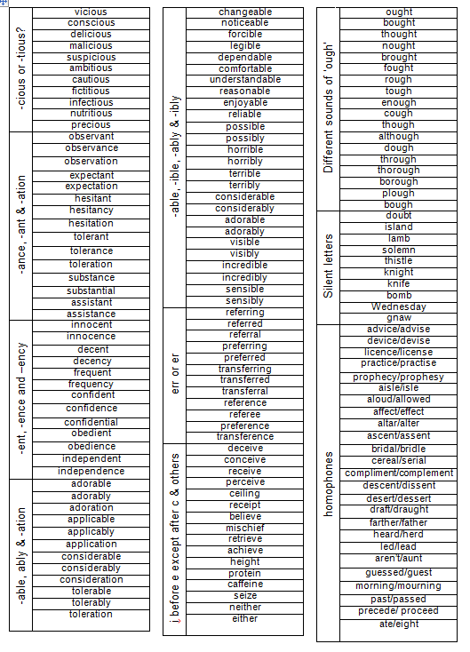

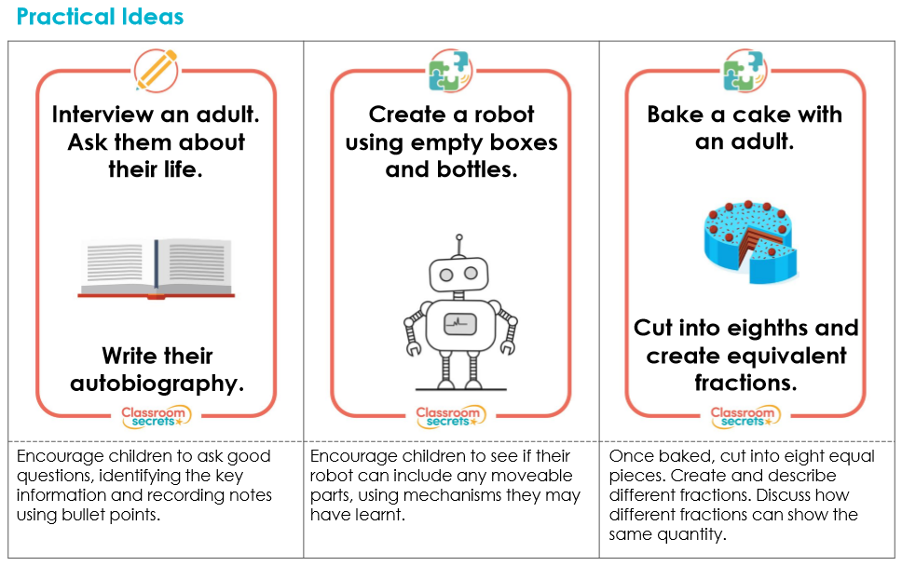
Practical Ideas for Home Learning:

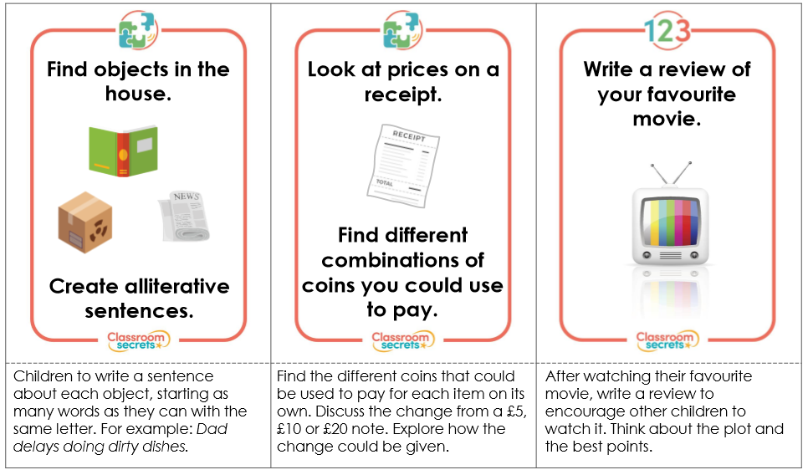

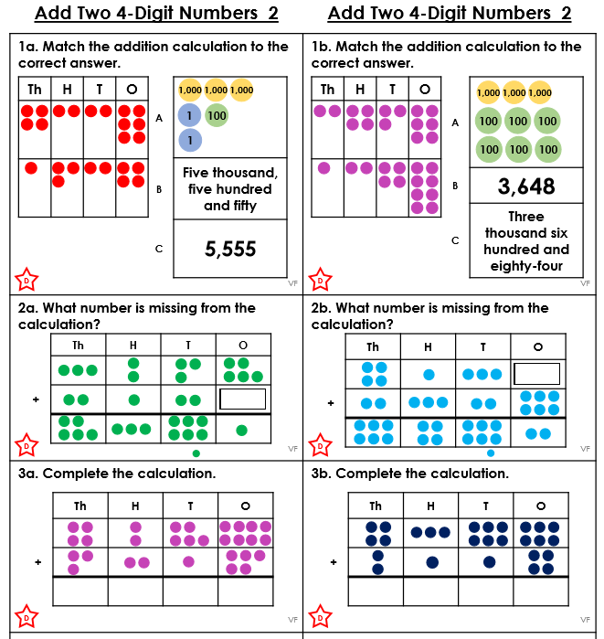
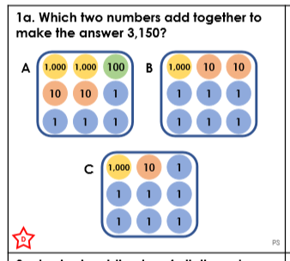

Problem Solving:
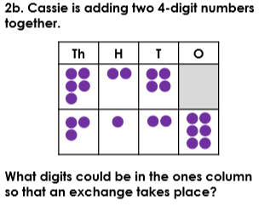

Answer:
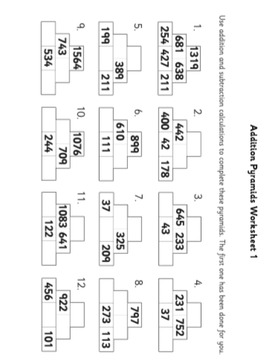
Pyramids: remember, the two numbers directly next to each other need to equal the number above!
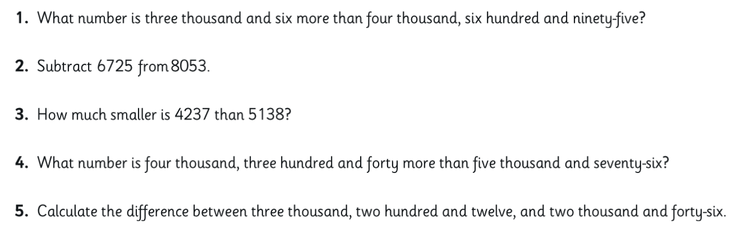
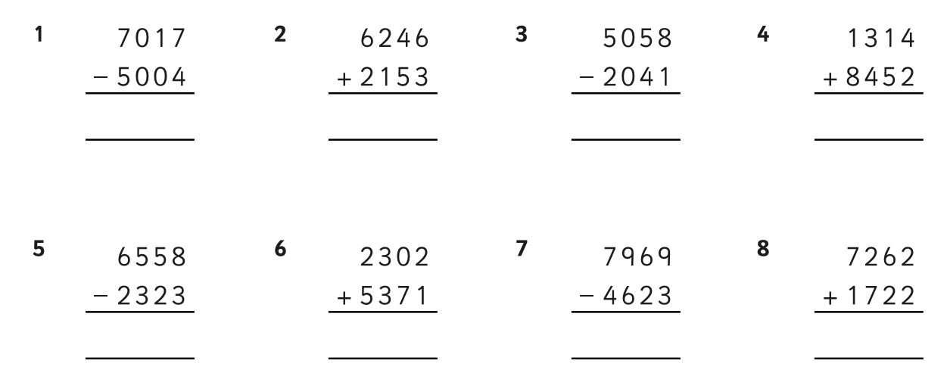
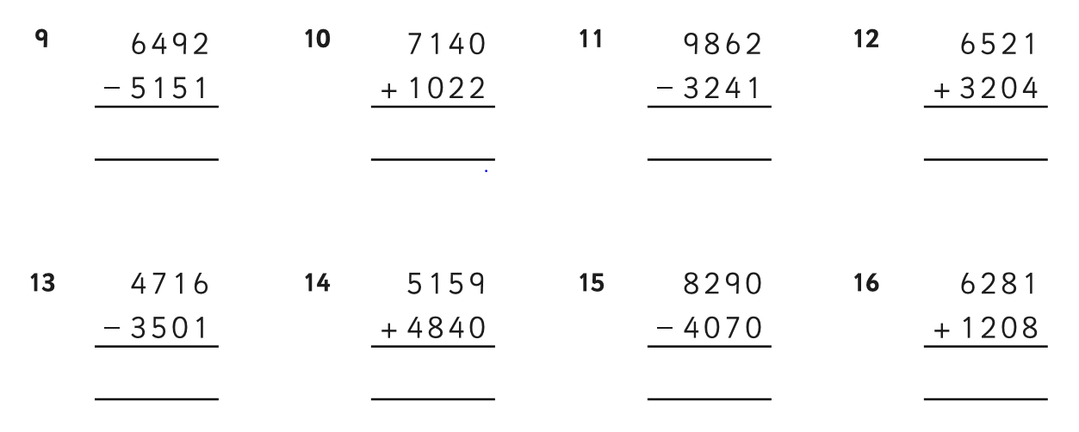
Column addition and subtraction:
Challenge:
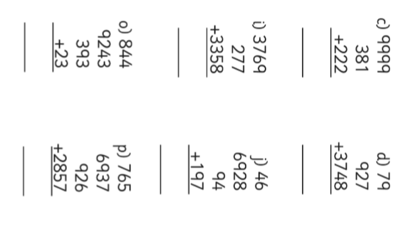
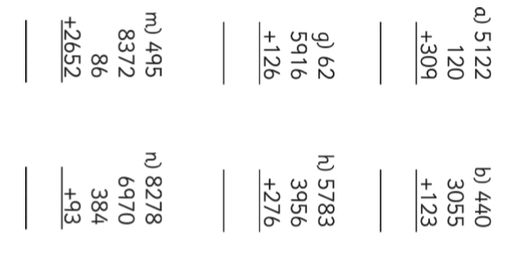

GPS Tasks
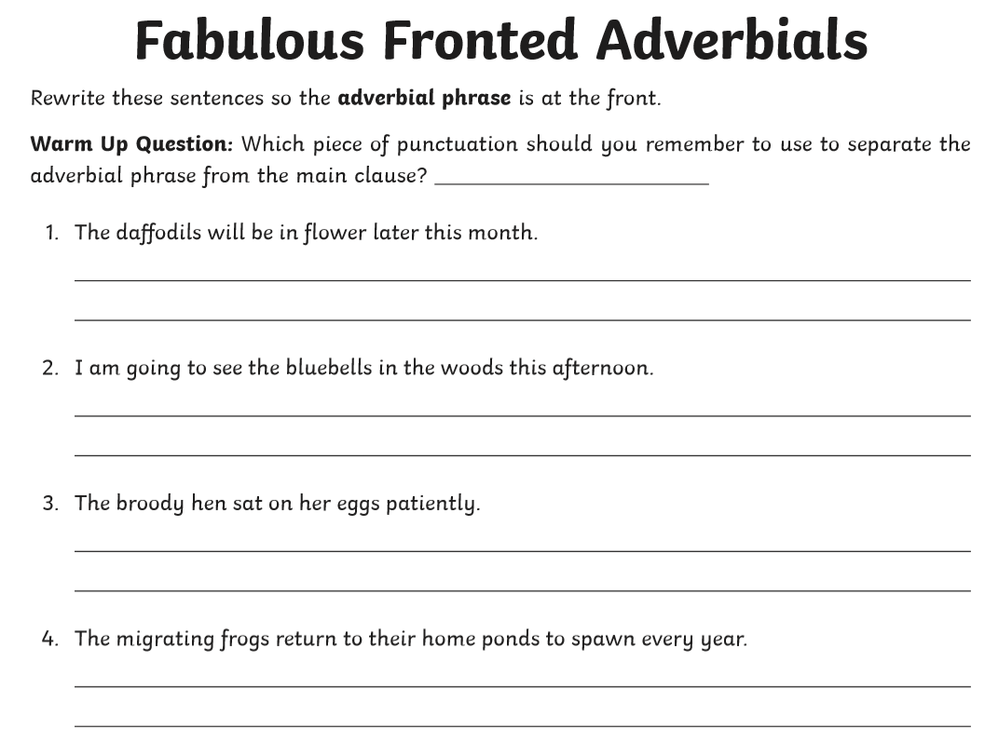

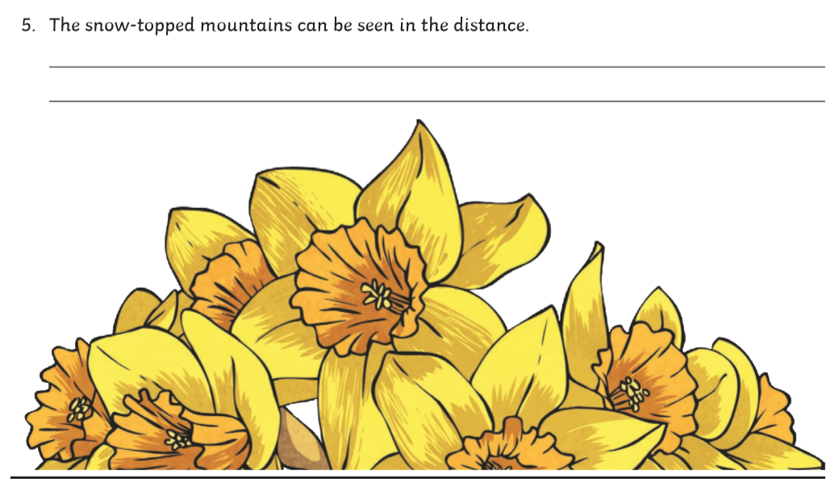

Can you add in the punctuation that’s missing? You can either re-write it or add it in to the text!
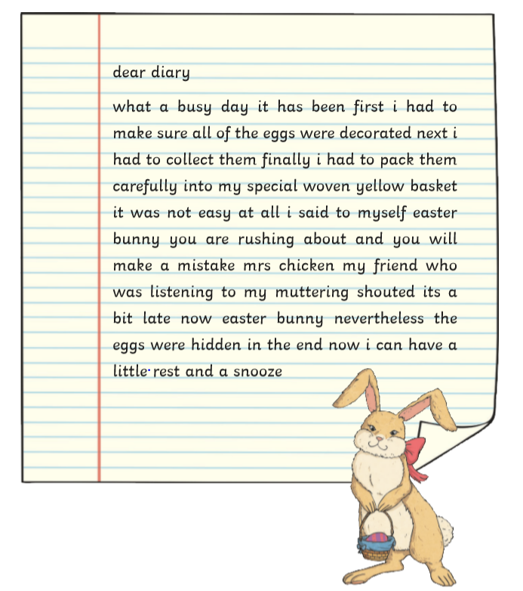

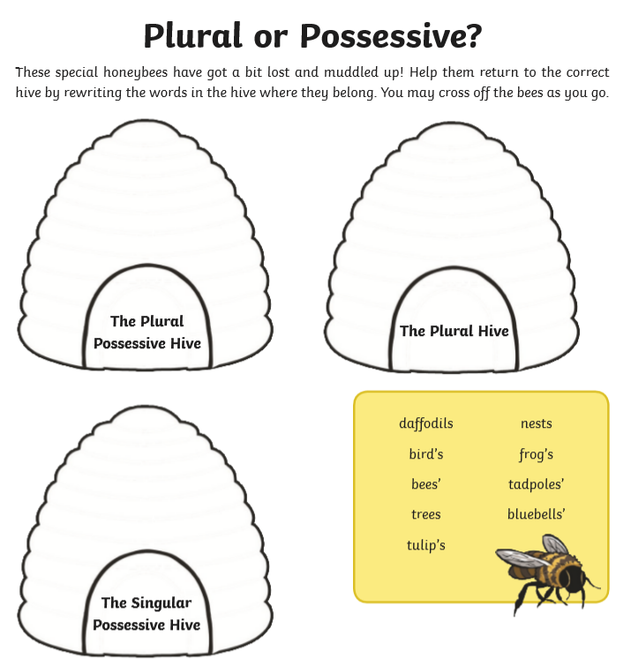
GPS: Possessive or Plural

