In Focus: Travel from start to finish by moving horizontally or vertically to a larger number each time.

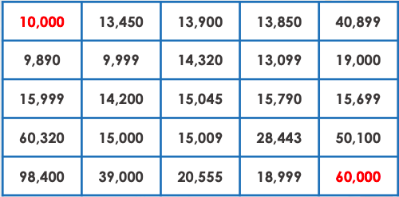

In Focus: Travel from start to finish by moving horizontally or vertically to a larger number each time.

Have a go at these challenges in your books:
