Ancient Egyptians: Tomb Challenge
A tomb was an important, decorative vault where the Ancient Egyptians were buried after death. They were sacred places that were often covered in hieroglyphics and drawings.
Below is a list of ideas as to how you could create your very own Ancient Egyptian Tomb. You can use any resources you have, not just our suggestions.
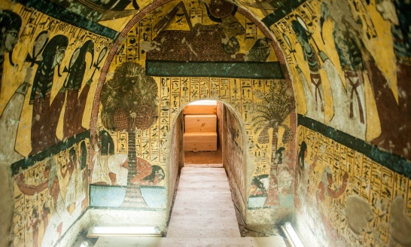
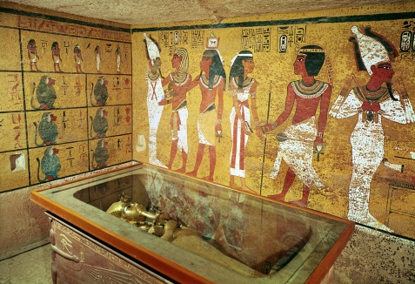
Let us know on Class Dojo which ones you try out!

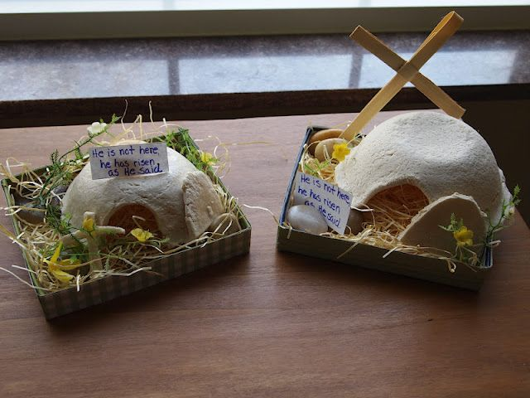

- Egg Box (see picture example).
- Shoebox
- Cereal box
- Toilet/kitchen roll tube
- Any cardboard box
- Yoghurt pot
- Butter container
- Twigs (used to create a nest-type shape)

