Maths  Mon-Fri  Should be done in order | Daily times tables practise: see TT Rockstars – the winners will be announced shortly!
 | Monday  Negative Numbers | Tuesday  Negative Numbers  (Problem solving) |  | Wednesday  Counting in powers of 10 |  | Thursday  Counting in powers of 10 |  | Friday Consolidation:  Powers of 10 challenge  OR  Times Table Rockstars
English  Mon-Fri  Choose one-a-day.  Rye-Writers is best done on consecutive days. | Daily Reading (20 mins+ of a text of your choice) and spelling practice (Year 5 and 6 statutory words)
 | Rye Writers: Care home letters  THANK YOU FOR ALL YOUR FABULOUS LETTERS SO FAR!  This week, we would like you to continue with this task if you have not done so already.  We will be writing letters to the care homes local to Rye. You may write about the things you’ve been doing whilst in lockdown, share with them a story you have written or fill it with questions you might have for them. It is completely your choice. A letter from you will really lift their spirits.  Please make sure you do not give out any personal information. This includes your name, address and contact number. Your first name only is fine.  As they will be going to a variety of residents in different homes, please start the letter with a simple ‘Hello’. Remember, you can share the letters via an email to myself, or a photo on Class Dojo. |  |  |  |  |  | Reading  Day 1 – Read through the Ancient Egyptian Gods and Goddesses PowerPoint. Take notes on key points!  Day 2 & 3 – Gods and Goddesses comprehension.  Pick the level that is right for you. |  | Grammar, Punctuation and Spelling  Task 1: Read through the Gods and Goddesses information sheet.  Task 2: Answer the GPS challenges. These are based on the Gods and Goddesses text.
Curriculum
Choose one-a-day

.
 | Ancient Egyptian Challenges  Please see the attached sheet from last week. We will update these with new challenges next Monday!  There are lots of different practical activities to choose from revolving around the theme of Ancient Egypt.  You don’t have to complete them all! |  | Art – Self Portraits  Pharaoh portraits had a very specific style. Heads were almost always shown in profile (sideways) view.  It is easier to get the nose correct when drawing a face from the side.  Profile heads also allowed the artist to show the ear and headdresses or hair.  Read through the PowerPoint. We’d like you to create your own portrait of you in the style of a Pharaoh!  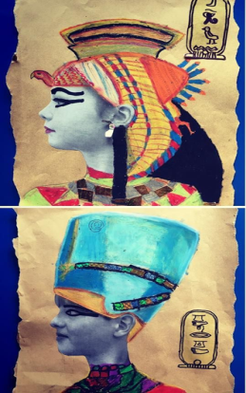 |  | PSHE/History  Right now, the whole world is speaking out against racism and the unfair treatment of black people, especially George Floyd who died on 25th May.  This has brought about a lot of discussion all over the world. Black Lives matter is an organisation in America, Canada and England created in 2013. Their mission is to end violence and unfair treatment towards Black communities. This organisation holds events to educate and inform people of what happens in their communities.  Task: Read through the PowerPoint, or if you can’t use the computer, read through the Newspaper printout.  We’d like you to create your own positive poster prompting fairness, justice and/or equality. You can focus on just one of these things, or all 3.  Think about what people can do to help, how we can show examples of these things, and the importance of treating people as we wish to be treated ourselves.

