March 2020

Dear parents, carers and guardians,
You have informed us you are self-isolating your child. Please find attached a pack of English, maths, science and topic resources and ideas to home-school your child.
This work is set for all children who are well enough to continue their learning. The pack contains enough work for the duration of their absence.
Thank you for your support.
Kind regards,
Mrs Smout and Mrs Banks
Orcas’ and Stingrays’ Teachers

English:
Reading
Please listen to your child read for at least 20 minutes each day. As this time also allows for talking about the text you will find additional ideas for discussion in this pack along with VIPERS talking-points which are also attached.

Spellings:
Below are the common exception words for year 3 & 4. These can be used for spelling practise and also handwriting. This should be a 20 minute daily activity. Your child might look for these words in their reading.

Check that all words can be read, and break them down into smaller groups to learn. In class we have been focussing on the prefixes and suffixes and what they mean aswell as how this changes the meaning of the word. Leave out the words that your child knows and focus on the ones they find trickier.

Common exception words for years 3 & 4
accident  actual  actually  address  answer  appear  arrive  believe  bicycle  breath  breathe  build  busy  business  calendar  caught  centre  century  certain  circle  complete  consider  regular  reign  remember  separate  sentence | continue  decide  describe  different  difficult  disappear  early  earth  eight  eighth  enough  exercise  experience  experiment  extreme  famous  February  forward  fruit  grammar  group  special  straight  strange  strength  suppose  recent | guard  guide  heard  heart  height  history  imagine  increase  important  interest  island  knowledge  learn  length  library  material  medicine  mention  minute  natural  naughty  surprise  therefore  though  although  thought | notice  occasion  occasionally  often  opposite  ordinary particular  peculiar  perhaps  popular  position  possession  possess  possible  potatoes  pressure  probably  promise  purpose  quarter  question  through  various  weight  woman  women

Writing:
Stories with a dilemma - 45 minutes a day
Use the plan on the next page to help write a story with a dilemma. Choose one of the pictures to help generate some ideas and use the DADWAVERS plan to help think of some descriptive writing features.
When they’ve finished the plan, they should write the story neatly and check their capital letters, full-stops, speech punctuation and spelling.

Grammar, Punctuation and Spelling
Editing the story.
Your child should read and check their punctuation and spellings in their writing.
We have recently been learning about using direct and indirect speech in writing so children should include these carefully. You will also find attached work on suffixes.
In year 4 we have also focussed on the use of different sentence structures (such as fronted adverbials and compound sentences) to make the writing more interesting. Children also need to include a range of descriptive words (adjectives and adverbs) and access to a dictionary and a thesaurus will be helpful.

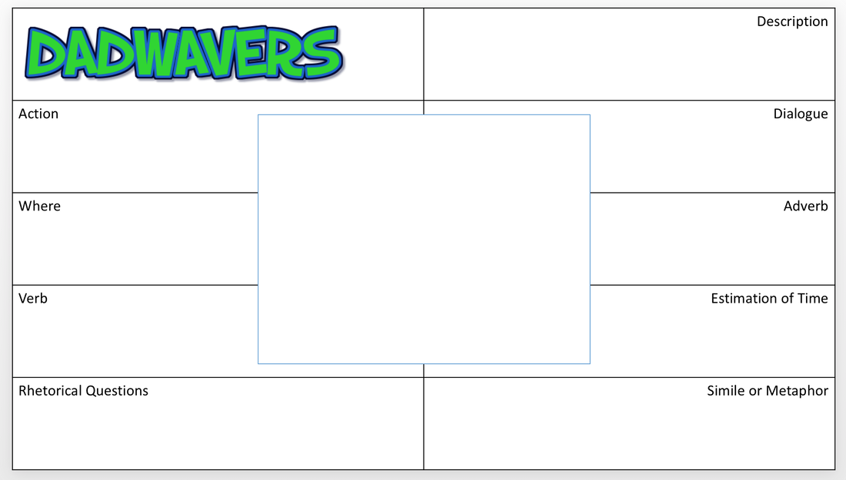

Maths:
TT Rockstars – at least 15 minutes a day.
All year 4 children have a login for ‘Times Table Rockstars. Please contact the school if you need another copy. If you cannot login on TTRockstars, attached is also a Xtable fun sheet with activities.
You will find, in the attached files, a range of maths activities, for fluency, reasoning and fractions. Each set has a number of pages which become increasingly challenging.
Choose one pack a day and give your child one of the pages to complete.
There is an answer page at the back of each PDF file!

Science:
This term’s science topic is Living Things and Their Habitats.
Can you create a habitat diorama? It should contain a producer, consumer (predator and prey). There are lots of examples on the internet for inspiration.
Topic
This term our topic is Blue Abyss

Please see the home-learning page and choose activities to complete.

GPS
Direct and Reported Speech
Reported speech:
- doesn’t use speech marks
- changes pronouns, and often also changes word order
- adjusts verb tenses (and time phrases if necessary)
- usually starts by telling you who spoke
- often uses “that…” – but you can omit it

Direct speech uses:
- speech marks
- the speaker’s actual words
- new speaker, new line
- Narration about who said it can go before, after or in amongst the speaker’s actual words.

Now use these rules to turn the following short sentences into reported speech.
- “I am going to ride my bike later,” said Paul.
Paul said he ________________________________________________________
- Katie announced, “My dog Lucy has just had puppies!”
____________________________________________________________________
Sometimes you need to add a connective so that your reported speech makes sense:
- “Make sure you put on suncream, Tim,” said Mum, “it’s a hot day.”
Mum told Tim to _____________________________________________________

____________________________________________________________________
- “Dad,” asked Hassan, “what is that big box for?”
____________________________________________________________________
- “I will pay you back next week, Bethany,” Adam promised.
____________________________________________________________________
Sometimes you need a different verb:
- “See this, Aysha?” Olivia called proudly, “it’s the birthday present my grandma gave me.”
Olivia proudly sh_____________________________________________________
____________________________________________________________________

