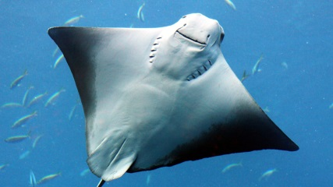
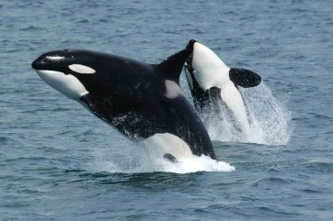

23 March 2020

Dear parents, carers and guardians,
School is now closed. We will care for all the children of keyworkers (when they cannot be cared for at home) and those with a social worker or an EHC plan.
If you have not done so already, please sign up to ClassDojo (download the app or sign up to the website). Logins have been sent home with the children on Friday, or emailed to you (please check spam). We will be using this platform to stay in touch. The school office may not be staffed at all times. The children will be able to upload pictues of their work, videos of new skills learnt to share with the rest of the class and you will be able to message us if you have any questions or want to share your child’s achievements. We will check messages regularly, between 8.30am – 3.00pm, Monday to Friday.
We believe the activities included in this pack and those that are attached will suffice for the week, however every child works and learns at a different pace, so please use the links provided on our classpages if you would like more work. We have also included some links to help support you.
Routines are very important to children. Please create a timetable with your child that will work for you, with the resources you have available. We realise most of you will have once computer to share between several people. Include time for exercise. We will post an example time table on our ClassDojo stories page.
Thank you for your support.
Kind regards,
Mrs Smout and Mrs Banks
Orcas’ and Stingrays’ Teachers

English:
Reading
Please listen to your child read for at least 20 minutes each day. As this time also allows for talking about the text you will find additional ideas for discussion in this pack (Top Tips and VIPERS talking-points). Now that libraries are closed, it may be difficult to get books for your child. On our class pages we have links to Oxford Owl. ReadTheory is a great site that will test your child’s comprehension skills. Please use it once a week. Login is in the front of your child’s orange book. Twinkl also has a variety of text, including non-fiction and poetry.

Spellings:
Below are the common exception words for year 3 & 4. These can be used for spelling practise and also handwriting. This should be a 20 minute daily activity. Your child might look for these words in their reading, create a cross word or wordsearch. Learn calligraphy or create word art.

Check that all words can be read and the meaning is understood. Break them down into smaller groups to learn. What do prefixes and suffixes mean and how do they changes the meaning of the (root)word? Leave out the words that your child knows and focus on the ones they find trickier.

Common exception words for years 3 & 4
accident  actual  actually  address  answer  appear  arrive  believe  bicycle  breath  breathe  build  busy  business  calendar  caught  centre  century  certain  circle  complete  consider  regular  reign  remember  separate  sentence | continue  decide  describe  different  difficult  disappear  early  earth  eight  eighth  enough  exercise  experience  experiment  extreme  famous  February  forward  fruit  grammar  group  special  straight  strange  strength  suppose  recent | guard  guide  heard  heart  height  history  imagine  increase  important  interest  island  knowledge  learn  length  library  material  medicine  mention  minute  natural  naughty  surprise  therefore  though  although  thought | notice  occasion  occasionally  often  opposite  ordinary particular  peculiar  perhaps  popular  position  possession  possess  possible  potatoes  pressure  probably  promise  purpose  quarter  question  through  various  weight  woman  women

Writing:
Stories with a dilemma
Use the plan on the next page to help write a story with a dilemma. Choose a picture and story starter on www.pobble365.com. Help generate some ideas and use the DADWAVERS plan to help think of some descriptive writing features.
When they’ve finished the plan, they should write the story neatly and check their capital letters, full-stops, speech punctuation and spelling.

Grammar, Punctuation and Spelling
Editing the story.
Your child should read and check their punctuation and spellings in their writing.They need to use a variety of punctuation: full stops, capital letters, commas, colon, semi-colon, question mark and exclamation mark.
We have recently been learning about using direct and indirect speech in writing so children should include these carefully. Direct speech should be punctuated correctly.
In year 4 we have also focussed on the use of different sentence structures (such as fronted adverbials and compound sentences – including how to use a comma with these) to make the writing more interesting. Children also need to include a range of descriptive words (adjectives and adverbs), so access to a dictionary and a thesaurus will be helpful. We have put word mats for you to download on our classpages.
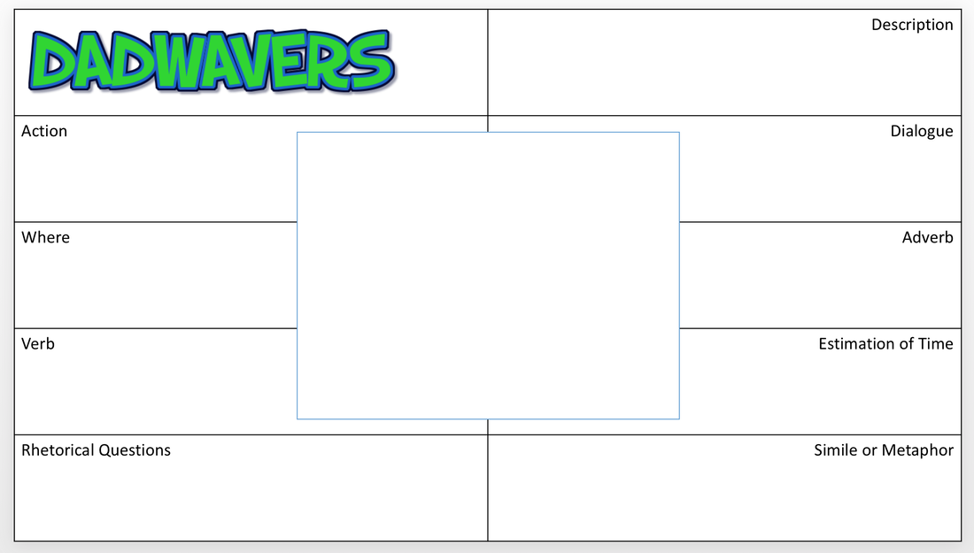
Maths:
TT Rockstars – at least 10 minutes a day.
All year 4 children have a login for Times Table Rockstars. Please contact us through ClassDojo if you need another one. There is a link for you to download and print additional times tables resources (Xtables fun sheet) on our class page.
You will find, in the links, a range of maths activities for this week, for fluency (fluent in 5), reasoning (rapid reasoning) and a consolidation pack. There is an answer page at the back of each PDF file! Please visit White Rose Maths, home learning, for a daily maths lesson, including video explanation.

Science:
This term’s science topic is Living Things and Their Habitats.
Can you create a habitat diorama? It should contain a producer, consumer (predator and prey). There are lots of examples on the internet for inspiration. We have also included a link to download a powerpoint with more information about habitats. Please share a picture of the finished product on ClassDojo.
For those children who have been in self-isolation last week and may have finished their habitat, can you find and write information about the creatures in your habitat and how it shows a healthy, stable, food chain.
Topic
This term our topic is Blue Abyss. Please choose one of the home learning activities to complete. Your child can add this as a file or picture to their portfolio on ClassDojo.
