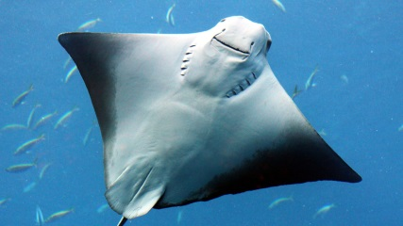
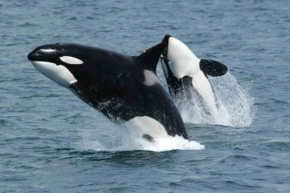

6 April 2020
Dear parents, carers and guardians,
We hope you are all well and in good health. We have put together a range of maths and English activities for this coming week, despite it being the Easter holidays. We felt it important to provide some continuity and it may also help the children from getting bored. Please feel free to do as much or as little of the work over this holiday period and as ever, most importantly, look after each other’s mental health.
If you have not done so already, please sign up to ClassDojo (download the free app or sign up to the website). Logins have been sent home with the children on the last day of school, or emailed to you (please check spam). We are using this platform to stay in touch. Many parents and children have shared pictures of the work and other activities they have completed.If you cannot find your login code, please let the school office know and we can make sure you will receive a login code.
We believe the activities included in this pack and those that are attached will suffice for the week, however every child works and learns at a different pace, so please use the links provided on our classpages if you would like more or different work. We have also included some links to help support you.
Thank you for your support.
Kind regards,
Mrs Smout and Mrs Banks
Orcas’ and Stingrays’ Teachers

English:

Reading: 20 minutes each day
Please listen to your child read for at least 20 minutes each day. As this time also allows for talking about the text you will find additional ideas for discussion in the previous pack (Archive: at the bottom of the class page). Now that libraries are closed, it may be difficult to get books for your child. On our class pages we have links to Oxford Owl. ReadTheory is a great site that will test your child’s comprehension skills. Please use it once a week. Login is in the front of your child’s orange book. Twinkl also has a variety of text, including non-fiction and poetry.

TALK every day:
- Make up stories but do not write them down every time.
- Make up false ‘news’ about what they MIGHT have done yesterday.
- Make up ‘fake news’ for things that would never happen but they would like them to e.g. the Queen or a pop star knocking at your door etc.
Write
- Write a letter to your grandparents and other family members.
- Write a script for a funny video. Record it and send it to family members to cheer up their day.
- Watch one of the daily videos and lessons on https://www.youtube.com/user/Devouefrenchbulldogs and write one of the learning chunks.
Maths:
TT Rockstars – at least 10 minutes a day.
All year 4 children have a login for Times Table Rockstars. Please contact us through ClassDojo if you need another one.
NumBots – all children can now use this site, using their TTRockstars logins, to practise addition and subtracting skills.
You will find, in the links, a range of maths activities for this week and a selection of easy to put together maths games to play at home. Previous work set can be found in the Archive (bottom of the page).
Join in with a maths reasoning lesson taught by Gareth Metcalfe on YouTube. Follow the link on the class page. He is continuing his fun investigations over Easter.

Science:
This term’s science topic is Living Things and Their Habitats.
Please continue and finish work on your diorama. Please share a picture of the finished product on ClassDojo.

PurpleMash
Avatar challenge – Log in to PurpleMash On the top right hand corner click on the avatar (it should be a shadow). Go through the different selection to create your avatar. Please make it look as much as possible like you. Save it, download it and post it to your portfolio on Classdojo. We will put it on class story for you all to guess who it is.

Easter holiday learning
Include 3 art or craft activities a week. Loads on Google, Youtube, Twinkl, etc.
- How to make a… pom pom, paper aeroplane, cut-out dressing doll, dragon, boat, origami rabbit etc…
- How to draw a… portrait, figure, dog, cat, vase of flowers, boat, etc.
- How to paint.
- KidsArt and such have great ideas.
- Keep checking the class page and class Dojo Story for activities.
Learn new dances and games from Google / Youtube
Include singing: masses of songs and videos on Google / Youtube. Invent musical instruments if you do not have any (kitchen ware is very good for this) and play accompaniments. Make drums and march around the home, beating them.
Complete a timed lego challenge using the challenge cards.
Do you have an atlas? If not, use Google to draw or trace important maps e.g. A map of the United Kingdom, naming the 4 countries and the seas around. A map of Great Britain naming important cities e.g. London, Birmingham, Bristol, Manchester, Leeds, Newcastle, Edinburgh, and Glasgow etc. A map of East-Sussex, a map of Europe naming the countries.
Play games on a map of the world e.g.
Fastest to Spot… for countries and seas and oceans etc.
Study something you liked in history e.g.
- Cave men.
- Egyptians.
- Henry VIII.
- Christopher Columbus.
- Victorians.
- First World War.
- Second World War.
- Study space flight / history of space travel and build a rocket.
- Make a Victorian room: cardboard box on its side (bigger the better: carpet the floor; make patterned wallpaper and paper the walls; make lots of little paintings and portraits and stick on walls; make a door and furniture with card and glue or staples; make little figures in costume to put into it.
Study famous people you enjoyed learning about e.g.
- Florence Nightingale.
- Samuel Pepys.
- Julius Caesar.
- Nelson Mandela.
- Paul McCartney.
- Tutankhamun.
- Joan of Arc.

Most importantly: Laugh!

