Greek and Roman Pottery

http://www.ancienttouch.com/roman-pottery-openshapes.htm

Do an image search using google.co.uk and type in Roman Pottery and click on ‘images’ for lots of pictures

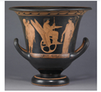
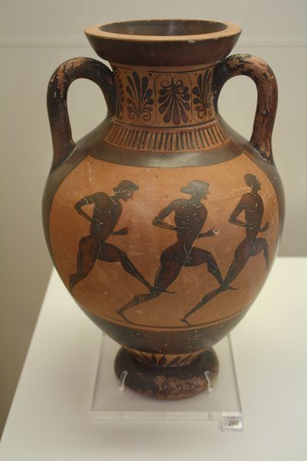

Use the designs to inspire you to draw and paint your own Greek or Roman pottery. Think about the shape and design of your pottery, sketch it first then use watercolour paints or pencils to colour.

