English w/c 6 July

Monday – Lesson 1
Read ‘The Sound Collector’ by Roger McGough https://vimeo.com/20373107
The poet really explores the lens of Checking (hearing, listening) from the writing rainbow.
Explore the structure – what is each verse about?
Positive or negative?
Are there rhyming words?

Lesson 1 activity
Cut up the poem and ask children to connect the verses with their subject shapes. Rebuild the poem.

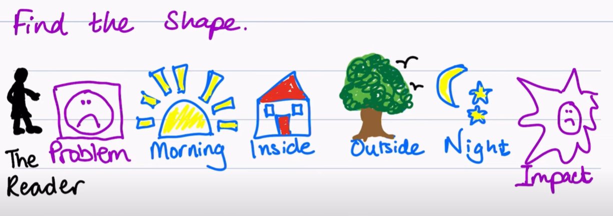

Tuesday – Lesson 2
Read the poem again. We are going to rewrite this poem using colours.

Lesson 2 activity
Collect good words for colours, using books you have or the internet. You can use the colour mats to help.
Think about what the colours looks like. What does indigo look like? Teal? Ruby?
What emotions do these colours make you feel? What objects are these colours?
Which colours are inside colours or outside colours?
Which colours are morning colours and which ones are night colours?

Wednesday – Lesson 3
Using the poem as a model, rewrite the first verse using colours with the lens of noticing (looking) and the lens of rhyme from the writing rainbow. Remember the rhyme scheme ABCB (the second line rhymes with the last line).

A stranger came this morning
All dressed in black and grey
Put every colour into a bag
And carried it away

Choose some morning colours and explore which ones you can make rhyme.
Example: yellow of the sunrise. Sunrise could rhyme with: surprise, eyes, cries
Example: sapphire of the sky. Sky could rhyme with: goodbye, try, high, nearby
Think about what will work and what won’t work. I am going to choose ‘high’ to rhyme with sky. A morning colour I can find up high could be …
Now that I have found my rhyme, I can add just add two more colours.

Thursday – Lesson 4
Using the poem as a model, rewrite the second verse using colours with the lens of noticing (looking) and the lens of rhyme from the writing rainbow.
Remember, you need inside colours for the second verse.

Example: beige of the curtain. Curtain could rhyme with certain.
Example: silver of the kettle. Kettle could rhyme with petal, settle. Maybe I could use silver of the spoons. Spoons could rhyme with moons. Maybe not moons as that is an outside colour.

