During an Olympic Games many national flags are on display.
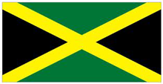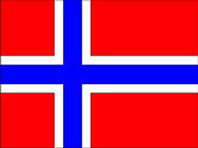
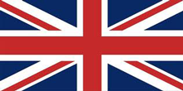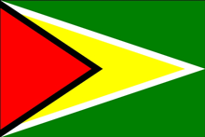
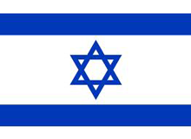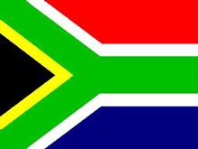

Pick a flag and investigate some of the following:
- What shapes can you see in it?
- Can you describe them and their angles?
- Does the flag have any lines of reflective symmetry, if so how many lines?
- Can you find any pairs of parallel lines? If so mark them on your flag.
- Are there any lines perpendicular to one another?
- Can you find a way to classify the shapes in your flag?
Now try with another flag.

