English overview for week starting 29th June 2020
Watch https://www.youtube.com/watch?v=PhdoTThn5mw
You are going to write a descriptive recount of the inspirational Olympic race run by Derek Redmond in the 1992 Olympic games.
Each day you will watch a short chunk of the film and write no more than 9 sentences about that chunk only.
The focus is to make sure that you include all 3 challenges for that day, focus on your grammar, spelling and punctuation and spend time on your vocabulary choices.
Each day there is a planning sheet to help you plan your work effectively before you write that chunk up.
Learning chunk/day | Challenges you must include | Additional information about the challenges.
Day 1  Learning chunk 1 (0 -35 seconds) | - Inner thought  - Adverb  - Simile | - What is the athlete thinking as he prepares for the race?  - Start your sentence with an adverb to describe when, how, or where the action is taking place.  - Describe the athlete using a simile (where something is described as being ‘like’ something else).
Day 2  Learning chunk 2 (36-1 min 10 seconds) | - Feeling  - Sentence structure (model sentence)  - Repetition | - How is he feeling as his hamstring snaps? Not just physically, but emotionally too?  - Use the model sentence below from the book ‘Of Lions And Unicorns’ by Michael Morpurgo and copy the structure. Remember to make sure your sentence is in past tense and third person (use ‘He’, not I…)  - Use some repetition for effect (examples below).
Day 3  Learning Chunk 3 (1 min 11- 2 min 4 seconds)  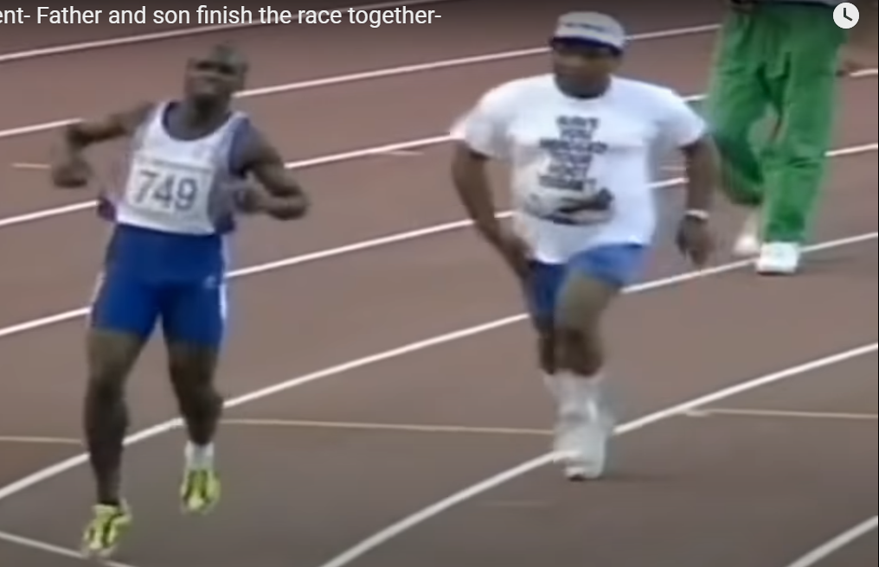 | - Action  - Speech  - Metaphor | - What action happened and by who? Use adverbs and adjectives (use the shade ‘ o meter to choose appropriate words).  - Use some dialogue either between the athlete’s father and the security guards, or the athlete and his father. (no more than three lots of dialogue).  - Use a metaphor to describe the athlete now.
Day 4  Learning chunk 4 (2 min 4 –end)  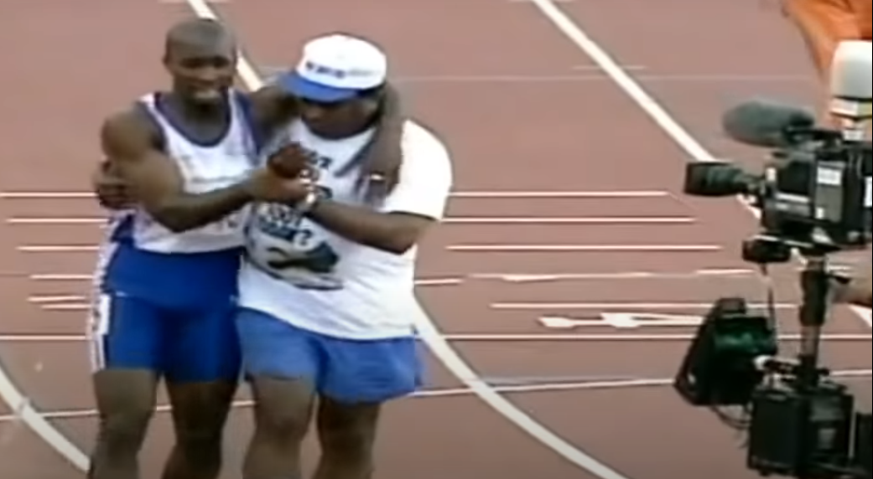 | - Touch  - Punctuation (use a De: de sentence)  - Alliteration | - In this section we see the athlete clinging on to his father. Can you describe this, thinking about ‘touch’ and describe this action in detail.  - Focus on using a De: de sentence (Description: detail) Examples below.  - Use some alliteration (Bravely he began to believe he could complete the race…)
Model sentence structure

“I used to have this dream that I was back home and the crowd was doing their chanting: “Billy, Billy the Kid! Billy, Billy the Kid!”
From the short story ‘Billy The Kid’ in the book ‘of Lions and Unicorns’ by Michael Morpurgo.

What features do you notice in this sentence? Make sure you change yours to ensure it is written in third person.

Repetition for effect
Let it snow, let it snow, let it snow.
"Oh, woeful, oh woeful, woeful, woeful day!
-Shakespeare, Romeo and Juliet
"And miles to go before I sleep, and miles to go before I sleep."

De:de sentence examples
Snails are slow: they take hours to cross the shortest distance.
I was exhausted: I hadn't slept for more than two days.

