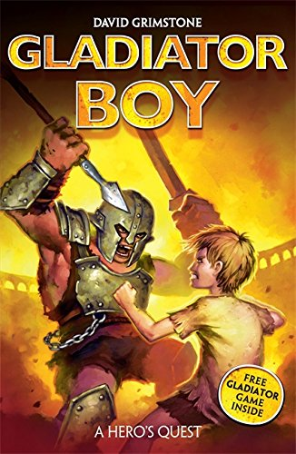
Gladiator Boy – Week 3
Day 1: draft and write to create characters and atmosphere.
Read the first paragraph of the model text.
Imagine how the jailer looked, draw him if you like. Find adjectives to describe him.
Your Task
- Write a detailed description of the jailer.
- What might a jailer say to the slaves as he woke them up/opened the doors/led them out into the arena?
- Include a sentence of speech.
Remember to:
Show, don’t tell (try not to start your sentences with ‘The jailer was…’, or ‘He looked…’, instead, think of different sentence structure to use.
‘Growling fiercely, the wrinkled jailer yanked the cell door open with his enormous arm.’
This way you ‘show’ the reader that he is fierce, old and strong without actually ‘telling’ them.

Day 2: draft and write to create characters and atmosphere.
Create a list of words to describe the trial masters. Not only their physical appearance but personality too. E.g. Aggressive, uncaring, formidable.

Your Task:
What changes could you make to the second paragraph -
- Where were the trial masters when they entered the arena?
- How could you describe them?
- What did they do?
- How did they make the slaves feel?
- What is the trial they set the slaves? What are the consequences if they fail?

Day 3 : Grammar and editing
Punctuate these sentences accurately.
Pull yourselves together yelled the ugly, scarred one. This is a test, which you cannot fail he continued.
Remember:
-inverted commas
-punctuation before closing inverted commas

Today we will be writing and improving the fourth paragraph where the main character helps his friend. Write your ideas on the following:
- What is the main character doing?
- What might he say to his friend?
- What advice could he give his friend? (remember the advice needs to match with your task/trial).

Your task is to write a paragraph describing how Decimus tries to help Gladius.

Remember to:
- Use your notes for your writing
- Use the model text for support
- Use a comma after a fronted adverbial
- Punctuate speech accurately

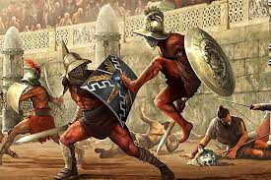
Day 4 : write an action opening

Use the picture as a stimulus to write your own action opening using the skills we have practised. You can cut out the picture and stick it into your book if you want to.

Remember to:
- Show, don’t tell!
- Use speech and punctuate it accurately (no more than 3 lots of speech, this isn’t a play script)
- Use exciting adjectives and adverbs (think of what you found earlier in the week)
- Use commas after fronted adverbials

