Can I animate my PowerPoint presentation?
Over the next few weeks we would like you to continue work on your powerpoint. Research the Romans and put the information on your slides.
To insert a picture, you need to save the picture from the internet and then follow the instructions below. Go to Insert, click on the picture and follow the prompts.
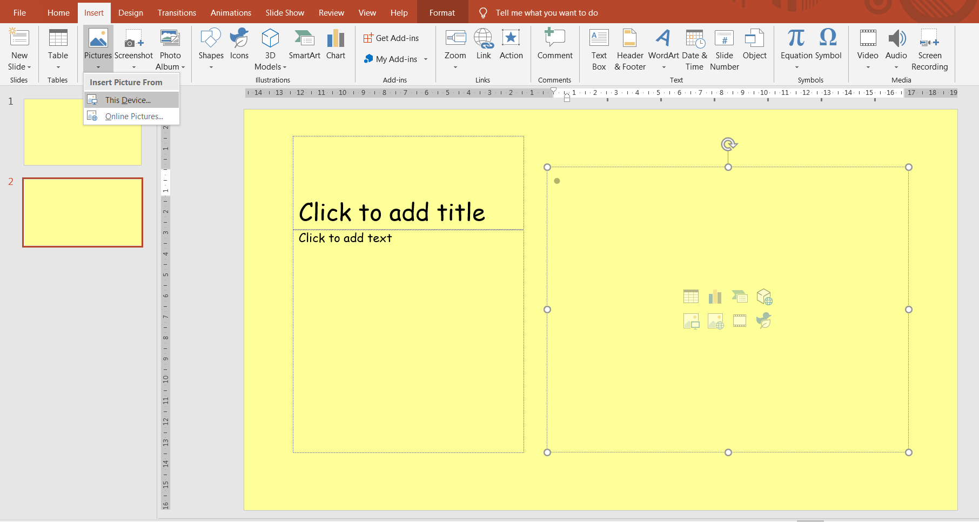
To give your presentation a wow factor, you can animate the information on your slides.
Click on the picture or textbox on your slide. Then select Animations at the top.
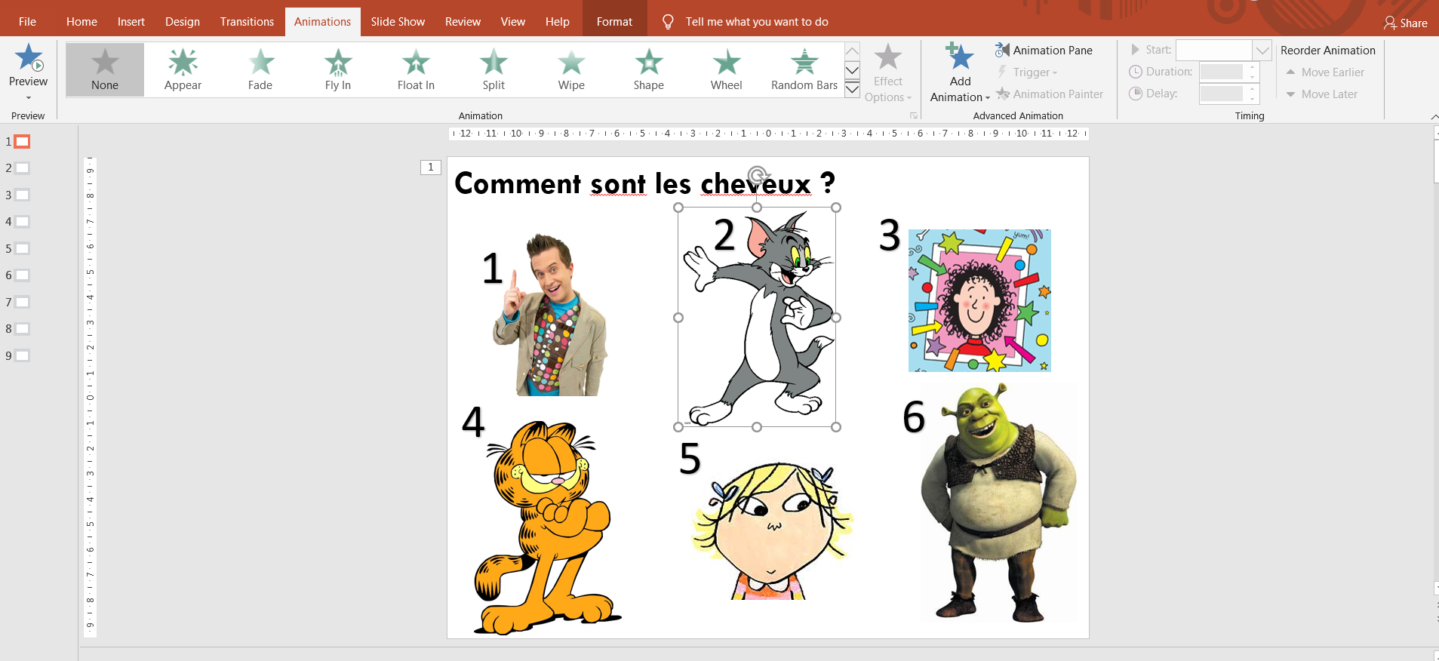
Each of the stars will give you a different effect. You can also choose exit animations.
Enjoy discovering the possibilities.

