Rye Writers VE Day evacuees
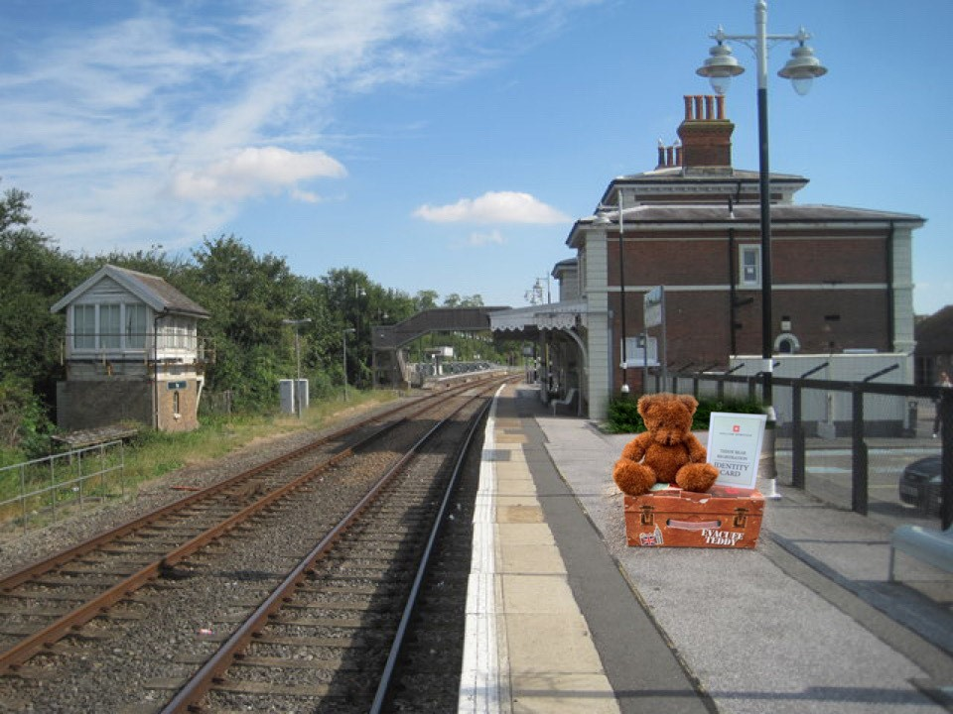
Friday 8th May is VE day. This marks the day when it was formally announced that World War Two had finished, with fighting ceased in Europe.
During WW2, many children were evacuated. This is when they travelled to safer countryside locations. Every evacuee was given food, a gas mask and a toy to keep with them. Often this toy would be a cuddly teddy bear.
This week, we’d like you to write a diary entry. It can be written from the point of view of either the bear (Tilly for a girl, Tom for a boy) itself, or a child carrying the teddy – it is up to you. Imagine you have been evacuated from your home, and have set off to travel to a new area. How would you be feeling? What ‘home-comforts’ would you miss? Can you describe your journey? Include powerful and emotive language, like you used in your persuasive writing last week.
There is a word mat to help you choose good vocabulary on the class page.

