Rye Writers – Magical Pathway
This week we would like you to write a story starting with this path, leading into the woods.
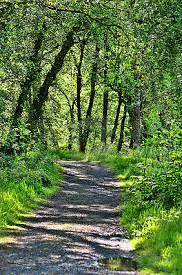
Where could this mysterious, woodland pathway take you? What might you find along the way? Where could it lead? What problems might you encounter? Create an adventure story imagining your journey began here, at the start of the path.
You have all been doing forest school. Try to remember what it was like in the woods. What did you see? What did you hear?
Attached are descriptive setting words to help you.
If you need some more inspiration, listen to this https://www.bbc.co.uk/sounds/play/p012shnf

