Task 1
Where does food come from for these animals?
Who eats what?
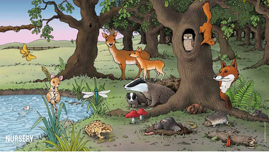
Task 2
Draw lines to show which of these is a consumer or a producer (copy the diagrams neatly into your books).

