**Year 3 – Can I subtract a 3-digit number from a 3-digit number?**

Task A

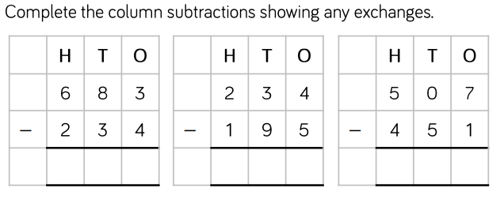

Task B

Find the missing values. Write it as a calculation.

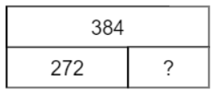 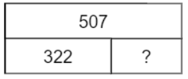 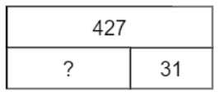

Find the missing digits.

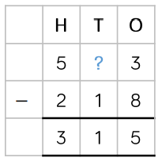 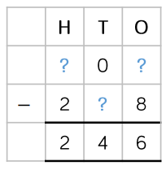

**Year 4 – Can I subtract a 4-digit number from a 4-digit number?**

Task A

Use column subtraction to work out the answers. Regroup when needed. 

Task B

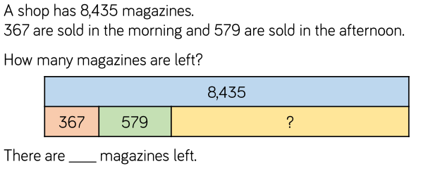1.

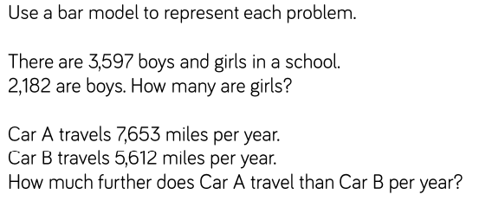

2.

3.

4.