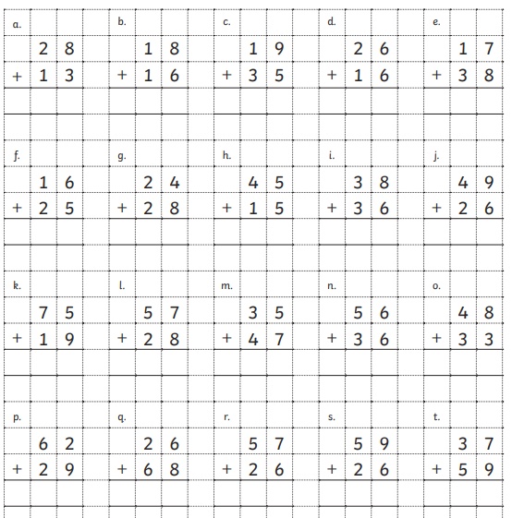
Write these in your books, draw the base 10 if you need to.

