Year 3

1) 2 + 5 =

2 hundreds. + 5 hundreds =

_________ + ___________ = ____________

2) 8 + 1 =

8 hundreds. + 1 hundred =

_________ + ___________ = ____________

3) 6 - 2 =

6 hundreds. - 2 hundreds =

_________ - ___________ = ____________

4) 4 - 3 =

4 hundreds. - 3 hundreds =

_________ - ___________ = ____________

Year 3

Use the bar model to write 4 different calculations:

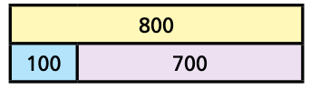

Use the bar model to write 4 different calculations:

Use the bar model to write 4 different calculations:

Use the bar model to write 4 different calculations:

