English Unit Plan
Experience day 1: Castles and knights (the Normans). What does a Norman Castle look like? Who worked and lived there? Gather setting vocabulary.
Experience day 2: Read the book up to page (chapter 2) Make a character profile of Tommy.
Writing lesson - plot point: 1  Can I write effective sentences for our story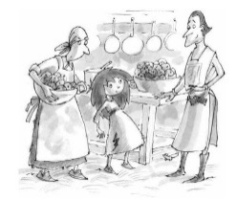 |  |  | Steps to success
FANTASTICs

Grammaristics
Boomtastics | Please copy and paste the Writing Rainbow Symbols into the relevant boxes.
Initiate |  | Model |  |  | Enable
Share plot point map with the class. We are going to write a mystery story with 7 paragraphs.  Tommy sees Sir Benedict talking with Mrs Moon.  What does she think? Use drama to elicit ideas. |  | From a distance, Tommy watched Sir Benedict talk with Mrs Moon. She crept closer. Worriedly, she thought …. |  |  | Children to write a sentence describing Tommy’s inner thoughts.  Deepen the Moment: include feelings.
Sir Benedict tells Tommy to report to the armoury early in the morning as she will be the new Keeper of the Blades.  Explore how Sir Benedict might talk. Use thesaurus thinking. |  | “Tommy, I have need of a new keeper of the blades. I think you will be perfect for the job,” said Sir Benedict in a ….. voice. |  |  | Children to write a sentence where Sir Benedict is addressing Tommy.  Deepen the Moment: include actions.
Tommy drops her bucket full of water in shock on the hard earth floor. What sounds can we hear?  Use sound clip. |  | Tommy gasped in surprise. Clang! The bucket Tommy was holding dropped to the flagstone floor. Slosh! The water went everywhere. |  |  | Children to write what we hear as Tommy drops her bucket in astonishment.  Deepen the Moment: free choice of lens

English Unit Plan
Experience day:
Writing lesson - plot point: 2  Can I write effective sentences for our story  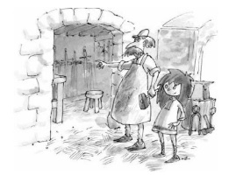 |  | Steps to success
FANTASTICs

Grammaristics
Boomtastics | Please copy and paste the Writing Rainbow Symbols into the relevant boxes.
Initiate | Model |  |  | Enable
Tommy arrives at the armoury. First impressions. Let’s describe what the room looks like. Show pictures of armouries on board. | 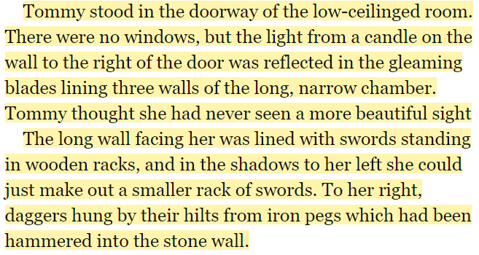 |  |  | Children to write a sentence describing the room with the swords.  Deepen the Moment: use inner thoughts.
Smith explains what Tommy needs to do and how. Author quote: The white elephant had to sleep between silk sheets (enormous ones), and eat mango flavoured Turkish Delights (tons of it) and have his tusks covered in gold leaf every morning. The Fireworkmaker’s daughter – Philip Pullman | “You’re to keep the blades polished and sharp (extremely sharp). You have plenty of cloths here (super soft) and a pot with oil for polishing it smelt nice). |  |  | Children to write their own sentence using the model to list Tommy’s tasks.  Deepen the Moment:
Tommy wants to prove she can do the job very well. Explore what is looks like to be motivated using a De:De sentence structure. | Tommy was eager to do well: she grabbed a cloth and started polishing the first sword she saw.  Tommy was keen to start: she wanted to be the best Keeper of the Blades ever. |  |  | Children to write their own sentence showing how Tommy is motivated.  Deepen the Moment:

English Unit Plan
Experience day:
Writing lesson - plot point: 3  Can I write effective sentences for our story.  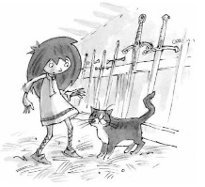 |  |  | Steps to success
FANTASTICs

Grammaristics
Boomtastics | Please copy and paste the Writing Rainbow Symbols into the relevant boxes.
Initiate |  | Model |  |  | Enable
Tommy polishes the swords and feels Sir Walter’s sword. Word tennis (heavy, sharp, studded with rubies, feather light,…) |  | Halfway along the wall, she pulled a sword from the rack that made her draw her breath I awe. Studded with rubies at the hilt, its blade decorated with exquisite engravings. It was so precious she didn’t dare wave it about. |  |  | Children write a few sentences describing Sir Walter’s blade.
Lil, the cat tells her it belongs to Sir Walter the Bald. Tommy is astonished there’s a talking cat. Drama. What do people do when they are astonished?  Gather verbs and adverbs. |  | “That;s Sir Walter the Bald’s sword,” Lil, the cat, spoke. |  |  | Children copy link sentence and write own sentence showing Tommy’s shock at hearing a cat talk.
While polishing the swords. Tommy discovers that the ‘Old Wrecks’ can talk and they want to help her become the first girl squire. |  | Tommy was as surprised as … to find that the Old Wrecks, Smith had asked her to ignore could talk too. |  |  | Children to write a sentence containing a simile.

