Maths  Mon-Fri  Should be done in order | Daily counting from any number forwards and backwards. Counting in 2’s, 5’s and 10’s Practise writing numbers 1-20 in words.
 | Monday  Problem Solving  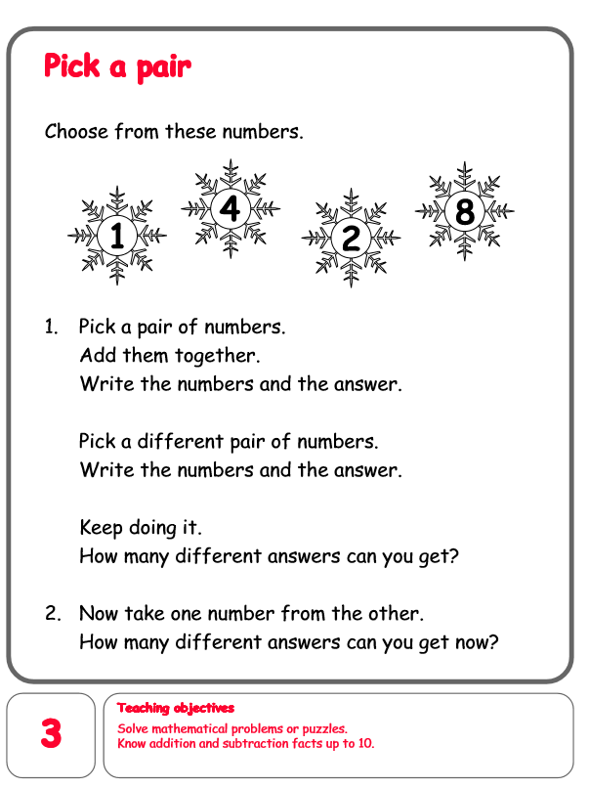 | Tuesday  Problem Solving  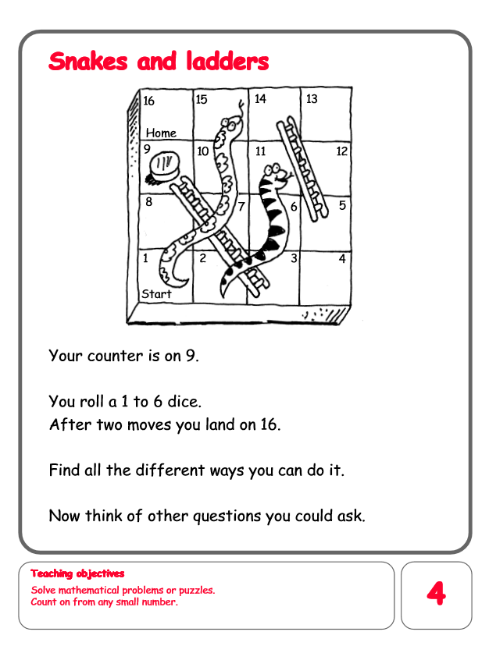 | Wednesday  Problem Solving  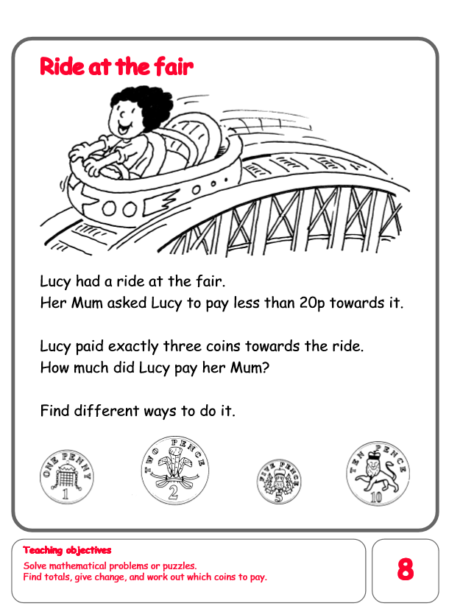 | Thursday  Problem Solving  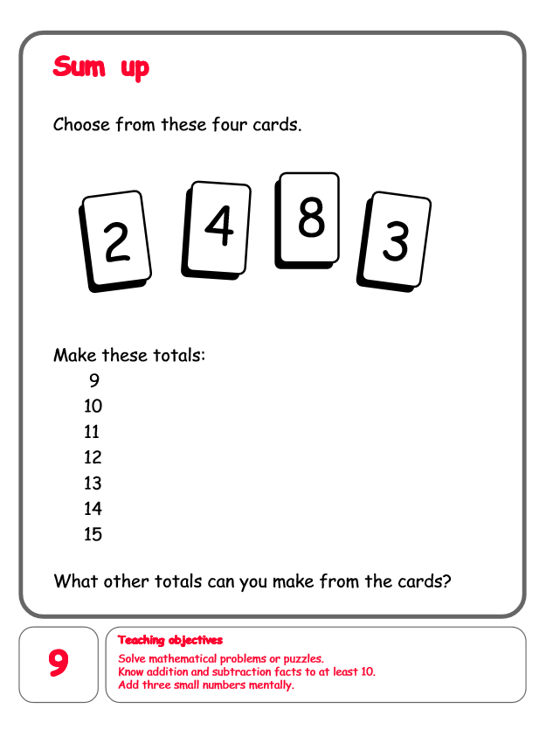 | Friday  Problem Solving  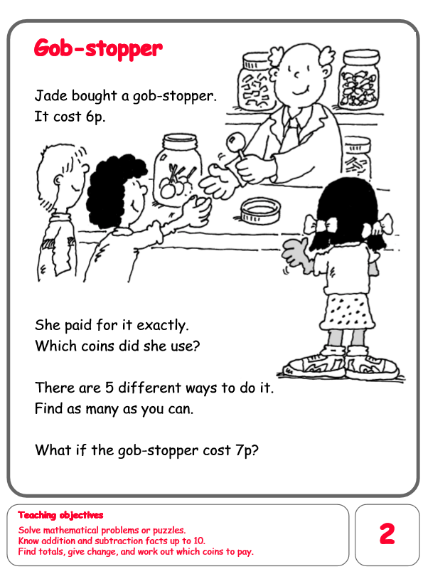
English  Mon-Fri  Choose one-a-day. | Daily Reading, Phonics ( Practise Phase 3 and Phase 5 sounds) and spelling practice ( Spellings- Common exception words and the days of the week ) Phonics game 2DO task on Purple Mash
 | To write a character description about the giant. | Grammar, Punctuation and Spelling  Using prefix un  Please complete worksheets. | Comprehension/ History  Victory in Europe Day  Please complete comprehension sheets. | Thursday and Friday  Rye Writers  Rye-Writers is best done on consecutive days. You can also choose when to do the 2 sessions could be on the same day, just do 2 curriculum subjects on the other day.  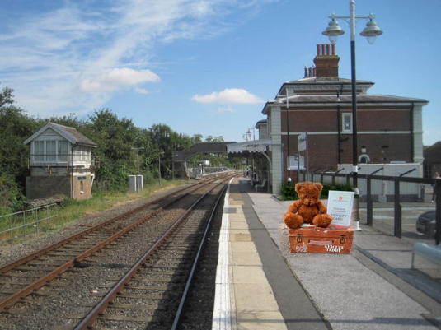  Activity: Evacuee Boris Bear has arrived in Rye. Please write a postcard home to his family telling them about his journey to his new home.  Please use Postcard template
Curriculum  Choose one-a-day. | Science  Look at the differences between deciduous and evergreen trees.  Power point  Activities. Draw and name pictures of evergreen and deciduous trees.  Go on a tree hunt looking for different types of evergreen and deciduous trees. | Geography  To draw a map of your ideal school playground and construct a simple key for it. | ICT  Purple Mash 2Do Task – Coding  Snail Race.  Create a race to find the fastest snail.  PSHE- Good Friend  Write a list of what you think makes a good friend.  Purple Mash 2Do Task | Art  Look at Gustav Klint’s Trees painting and draw, paint or collage your own version.  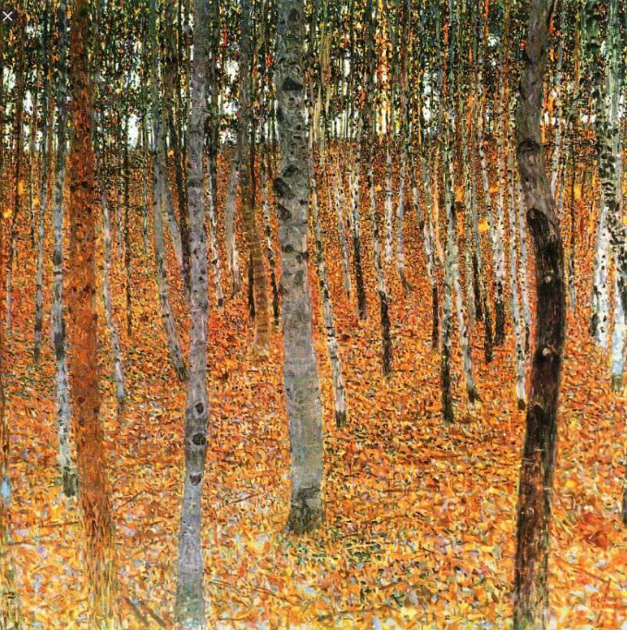 | STEM  Make your own Great British Bunting and display it in your window at home.  https://www.bbc.co.uk/programmes/articles/4TrqYDyf4PMdLypxzyTwGDg/great-british-bunting

